Reflection

Definition
# Source: AI Source: Provided by: [Data Path: Persons Table -> ID Column: 1, Name_En Column: Motasem Essam] -> From: [ChatGPT] on [7/25/2026]
Reflection is a geometric transformation that creates a mirror image of a figure across a fixed line called the line of reflection.
During a reflection:
- Every point is mapped to the opposite side of the line of reflection.
- Each point and its image are the same perpendicular distance from the line of reflection.
- The figure keeps the same shape and size.
- The orientation of the figure is reversed.
Therefore, reflection is a rigid transformation, and the original and reflected figures are congruent.
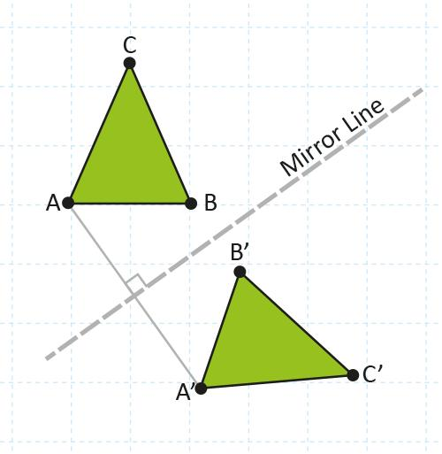
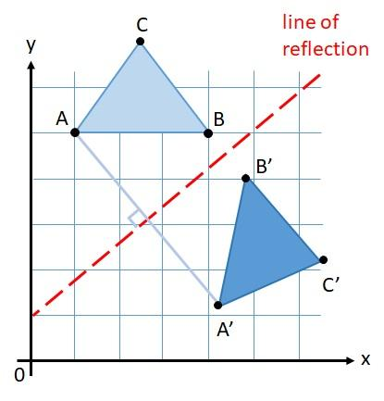
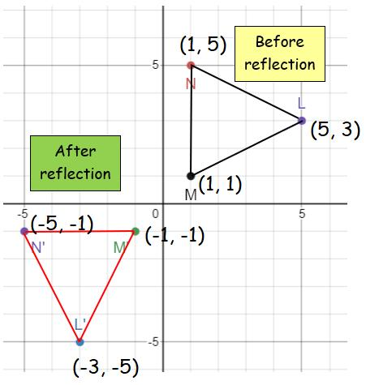
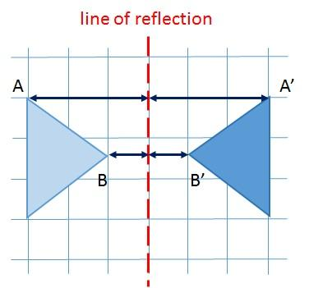
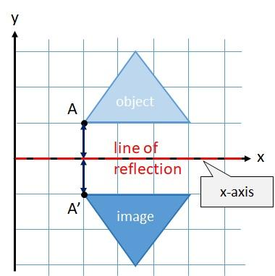
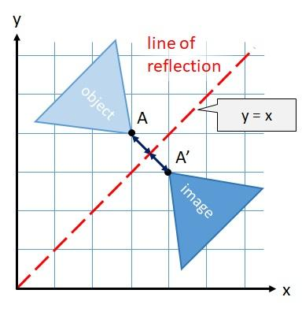

Purpose
# Source: AI Source: Provided by: [Data Path: Persons Table -> ID Column: 1, Name_En Column: Motasem Essam] -> From: [ChatGPT] on [7/25/2026]
Reflection is used to:
- Create mirror images of geometric figures.
- Study geometric transformations.
- Analyze symmetry.
- Transform coordinates.
- Understand orientation changes.
- Create patterns and designs.
- Model mirrors and reflective surfaces.
- Support computer graphics and CAD.
- Analyze architectural and engineering designs.

Fundamental Idea
# Source: AI Source: Provided by: [Data Path: Persons Table -> ID Column: 1, Name_En Column: Motasem Essam] -> From: [ChatGPT] on [7/25/2026]
A reflection flips a figure across a fixed line.
The fixed line is called the:
$$\boxed{\text{Line of Reflection}}$$
For every point $A$ and its image $A^{'}$:
- $AA^{'}$ is perpendicular to the line of reflection.
- The line of reflection bisects $AA^{'}$.
Therefore:
$$\boxed{d\left(A , l\right)=d\left(A^{'} , l\right)}$$
where $l$ is the line of reflection.
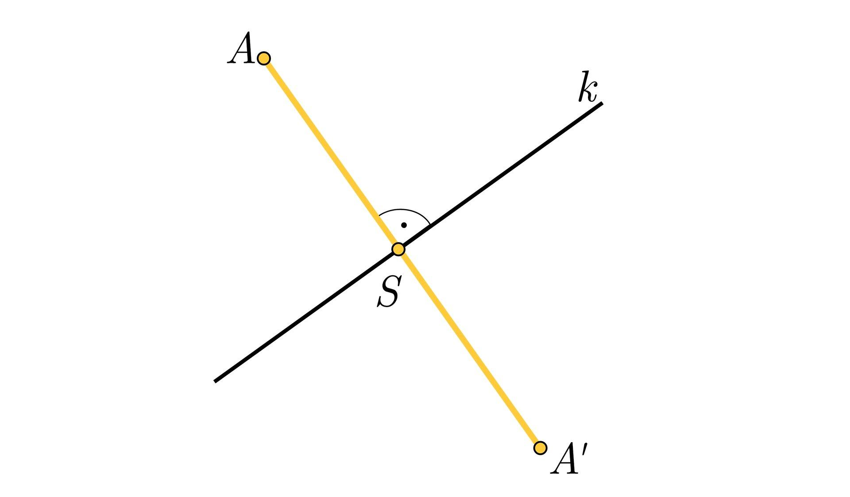
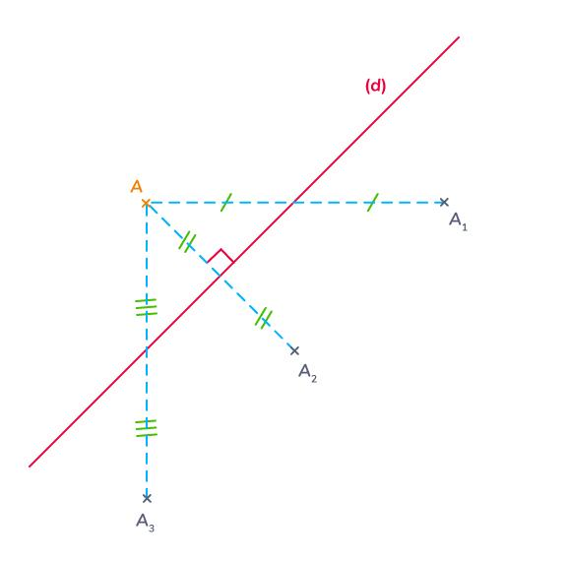
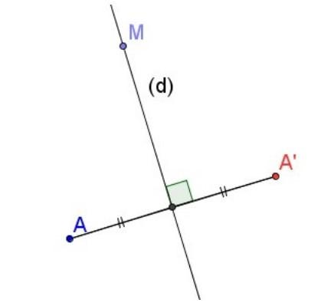
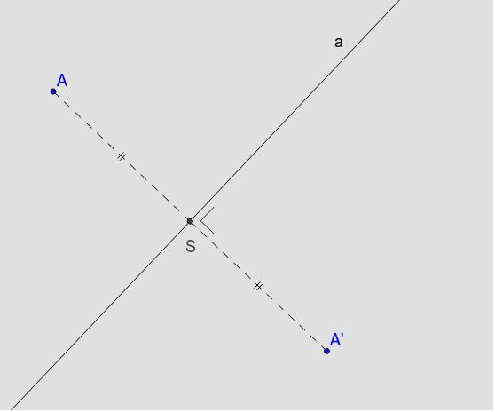
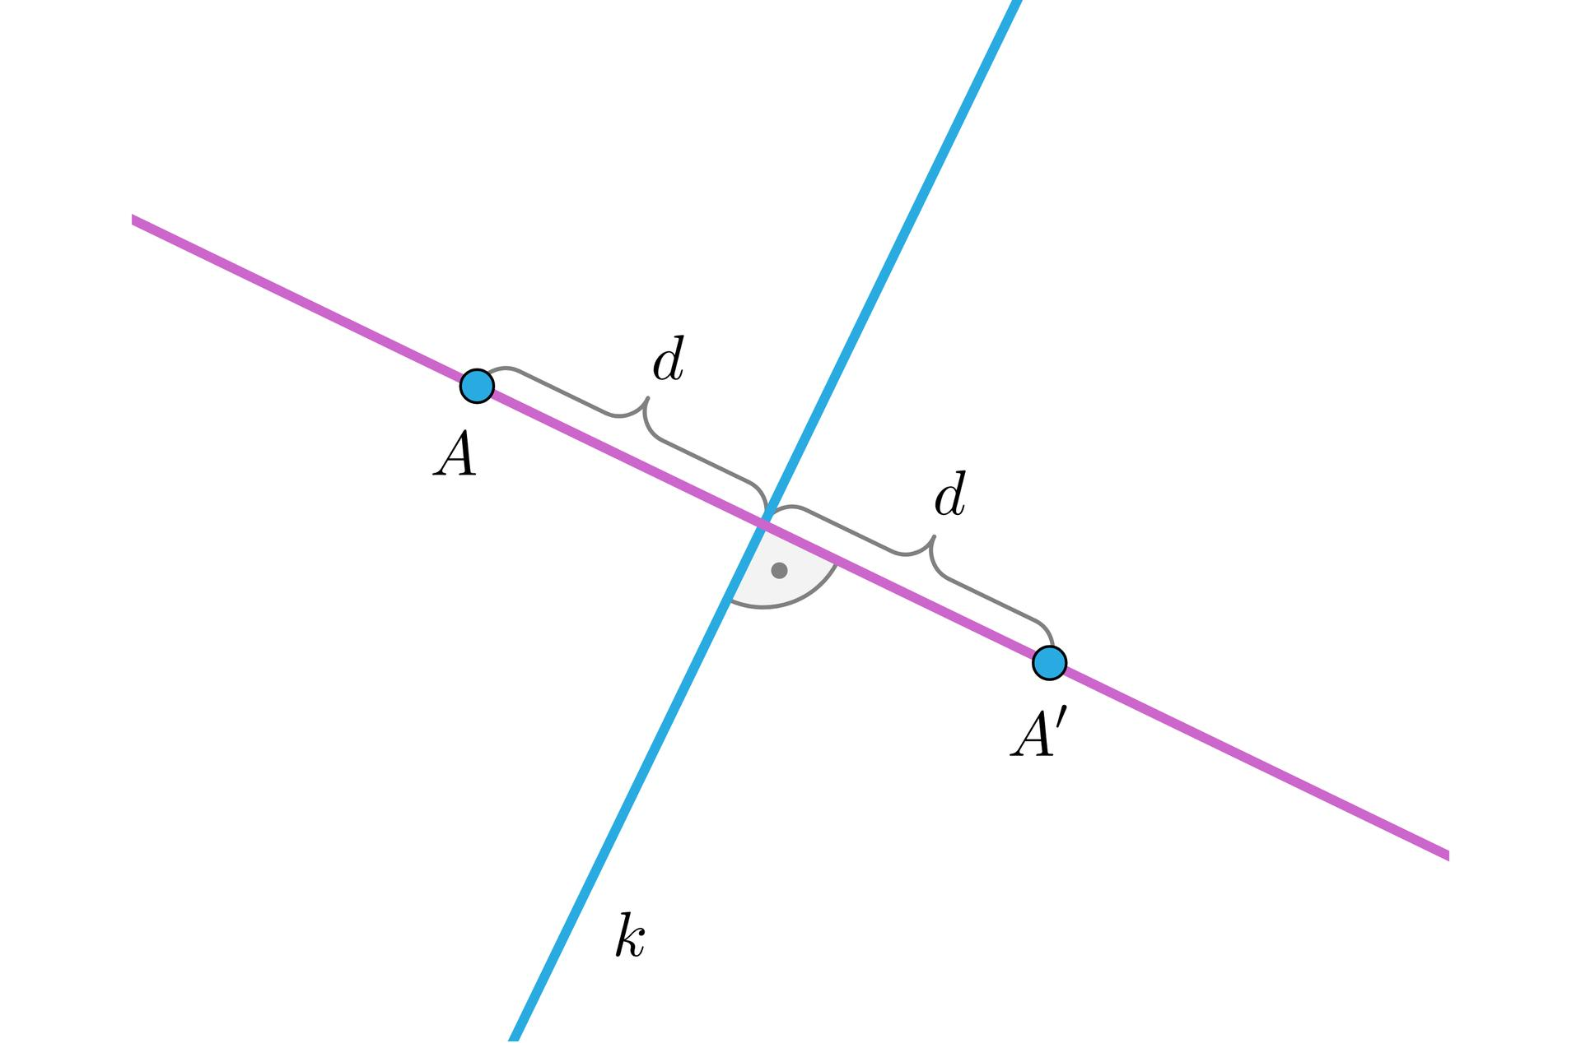

Line of Reflection
# Source: AI Source: Provided by: [Data Path: Persons Table -> ID Column: 1, Name_En Column: Motasem Essam] -> From: [ChatGPT] on [7/25/2026]
The line of reflection is the fixed line across which the figure is reflected.
Common lines of reflection include:
- $x$-axis
- $y$-axis
- $y=x$
- $y=-x$
- Any horizontal line
- Any vertical line
- Any arbitrary line
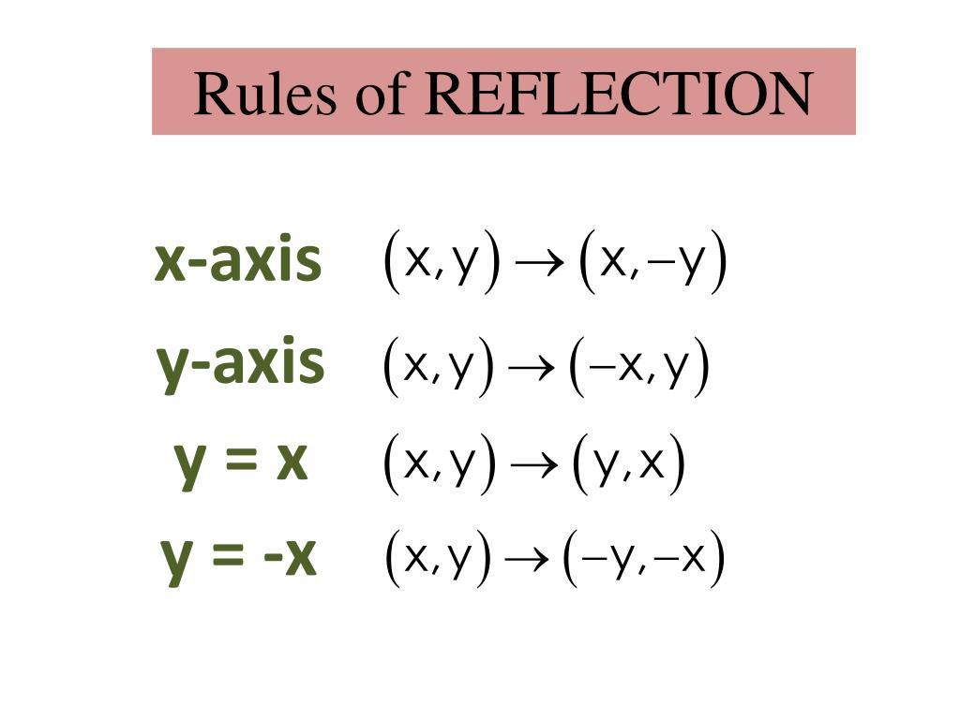
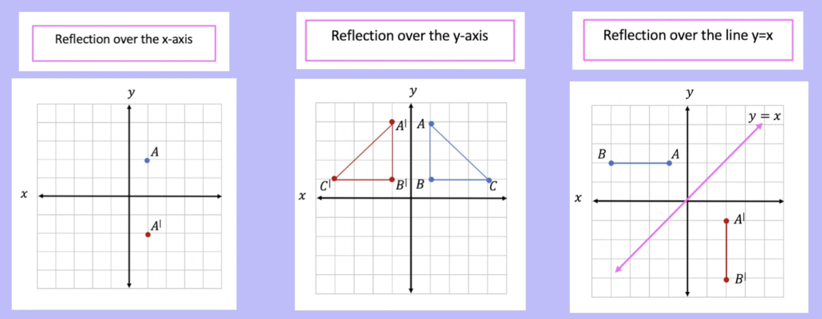
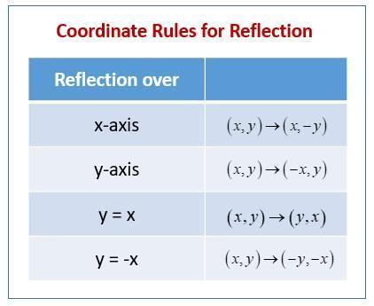
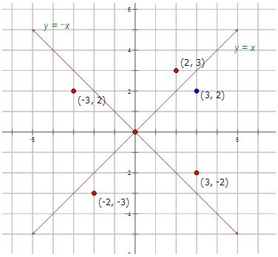
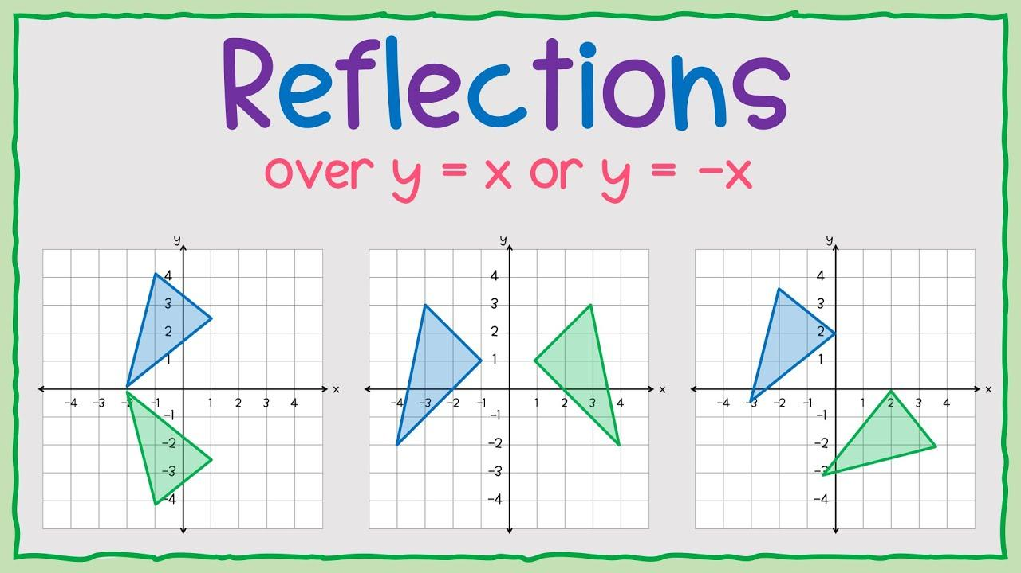
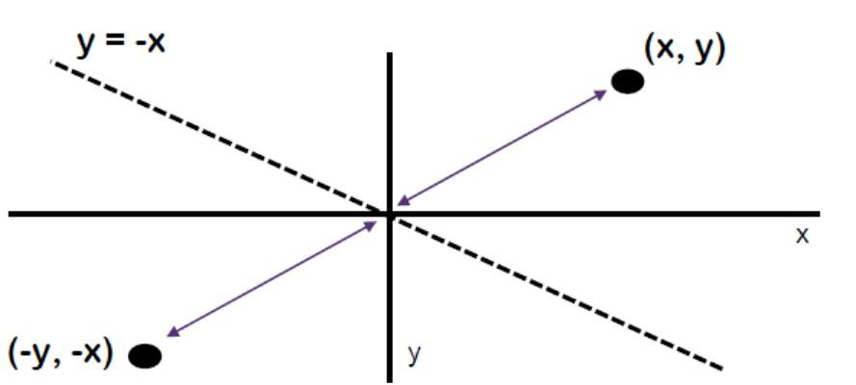

Reflection Across the $x$-Axis
# Source: AI Source: Provided by: [Data Path: Persons Table -> ID Column: 1, Name_En Column: Motasem Essam] -> From: [ChatGPT] on [7/25/2026]
When a point is reflected across the $x$-axis:
$$\boxed{\left(x , y\right)→\left(x , -y\right)}$$
The $x$-coordinate remains the same, while the sign of the $y$-coordinate changes.
Example
$$A=\left(3 , 4\right)$$
After reflection across the $x$-axis:
$$\boxed{A^{'}=\left(3 , -4\right)}$$
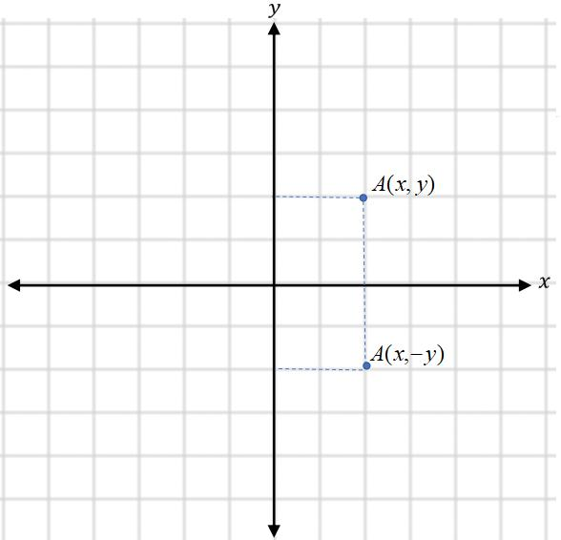
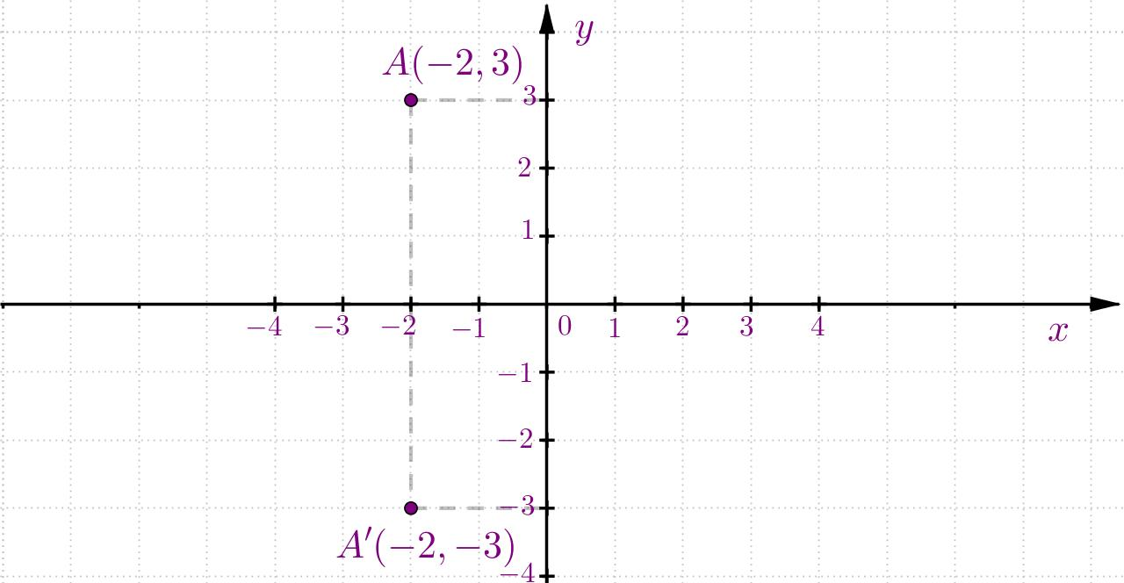
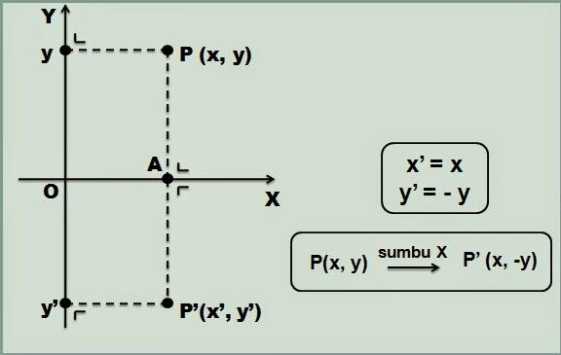
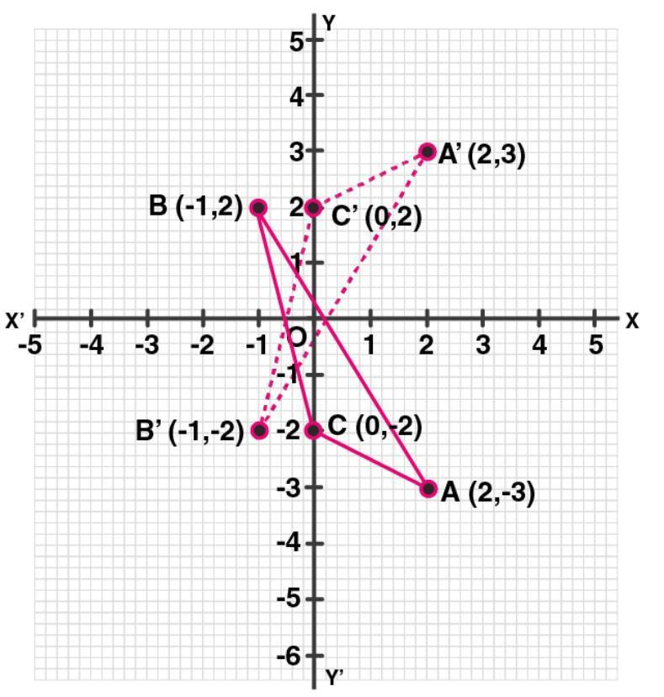

Reflection Across the $y$-Axis
# Source: AI Source: Provided by: [Data Path: Persons Table -> ID Column: 1, Name_En Column: Motasem Essam] -> From: [ChatGPT] on [7/25/2026]
When a point is reflected across the $y$-axis:
$$\boxed{\left(x , y\right)→\left(- , xy\right)}$$
The $y$-coordinate remains the same, while the sign of the $x$-coordinate changes.
Example
$$A=\left(3 , 4\right)$$
After reflection across the $y$-axis:
$$\boxed{A^{'}=\left(- , 34\right)}$$
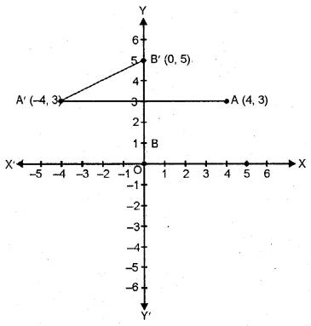
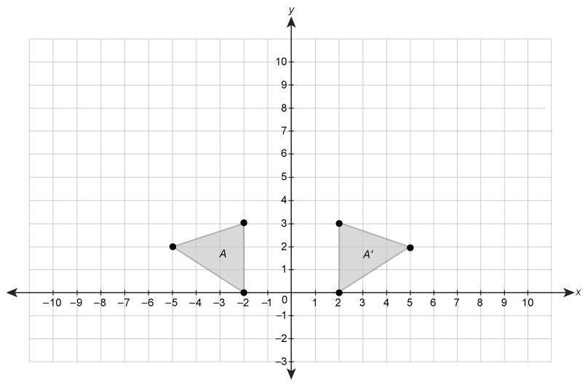
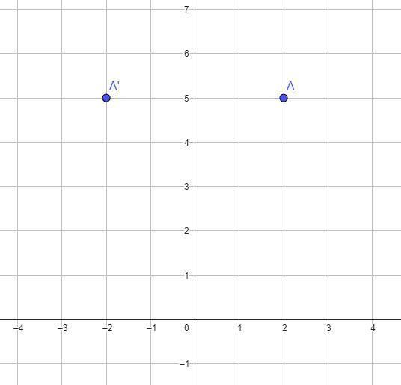

Reflection Across the Line $y=x$
# Source: AI Source: Provided by: [Data Path: Persons Table -> ID Column: 1, Name_En Column: Motasem Essam] -> From: [ChatGPT] on [7/25/2026]
For reflection across:
$$\boxed{y=x}$$
the coordinates are exchanged:
$$\boxed{\left(x , y\right)→\left(y , x\right)}$$
Example
$$A=\left(2 , 5\right)$$
becomes:
$$\boxed{A^{'}=\left(5 , 2\right)}$$
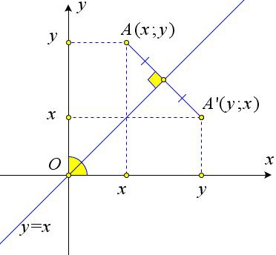
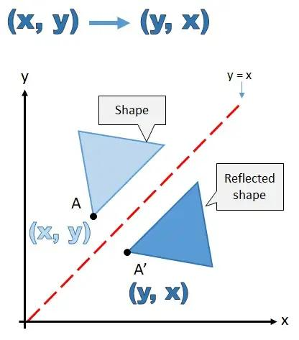
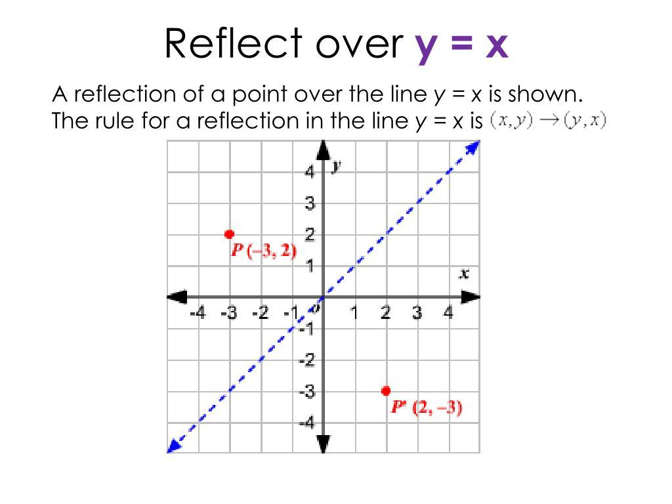
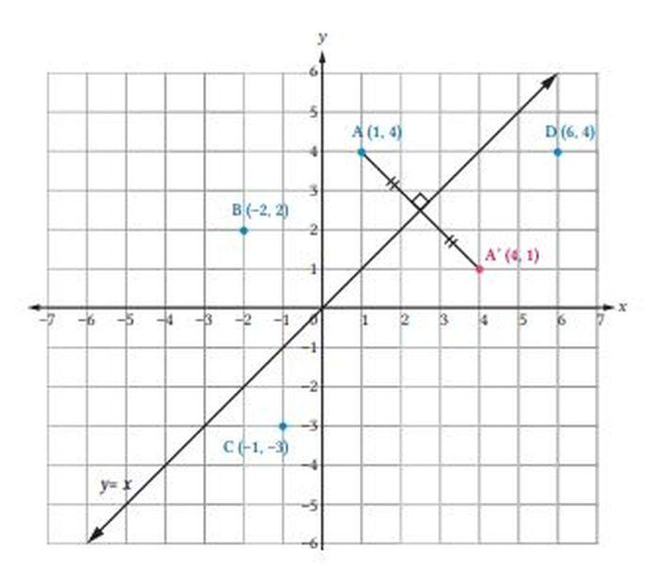
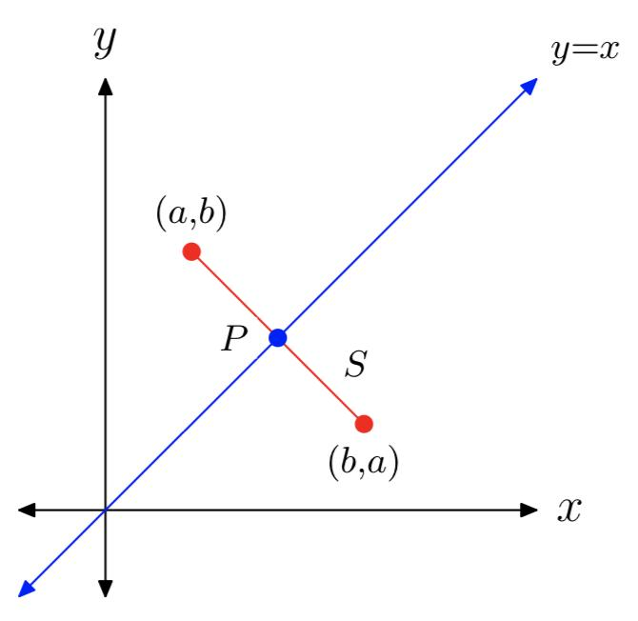

Reflection Across the Line $y=-x$
# Source: AI Source: Provided by: [Data Path: Persons Table -> ID Column: 1, Name_En Column: Motasem Essam] -> From: [ChatGPT] on [7/25/2026]
For reflection across:
$$\boxed{y=-x}$$
the coordinate rule is:
$$\boxed{\left(x , y\right)→\left(- , y-x\right)}$$
Example
$$A=\left(2 , 5\right)$$
becomes:
$$\boxed{A^{'}=\left(- , 5-2\right)}$$
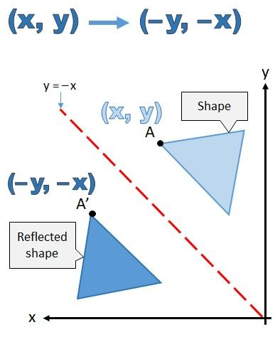
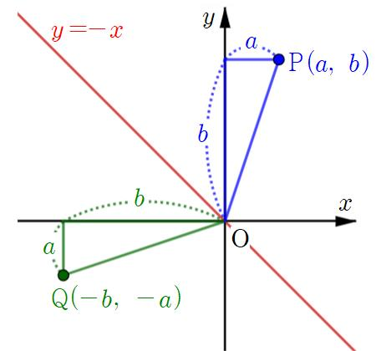
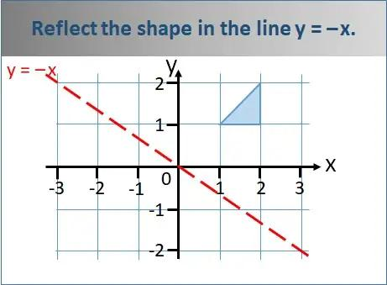
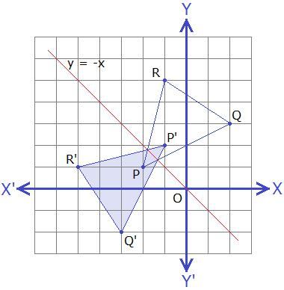
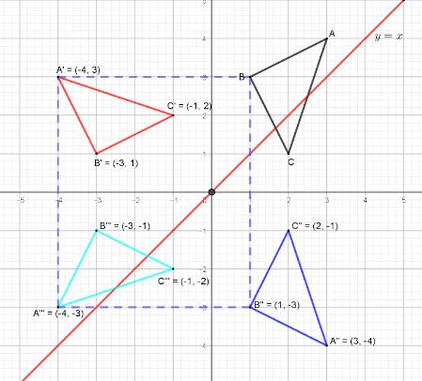

Reflection Across a Vertical Line
# Source: AI Source: Provided by: [Data Path: Persons Table -> ID Column: 1, Name_En Column: Motasem Essam] -> From: [ChatGPT] on [7/25/2026]
For a vertical line:
$$\boxed{x=a}$$
the reflection rule is:
$$\boxed{\left(x , y\right)→\left(2 , a-xy\right)}$$
Example
Reflect:
$$A=\left(3 , 4\right)$$
across:
$$x=5$$
Then:
$$x^{'}=2\left(5\right)-3 \\ x^{'}=7$$
Therefore:
$$\boxed{A^{'}=\left(7 , 4\right)}$$

Reflection Across a Horizontal Line
# Source: AI Source: Provided by: [Data Path: Persons Table -> ID Column: 1, Name_En Column: Motasem Essam] -> From: [ChatGPT] on [7/25/2026]
For a horizontal line:
$$\boxed{y=b}$$
the reflection rule is:
$$\boxed{\left(x , y\right)→\left(x , 2b-y\right)}$$
Example
Reflect:
$$A=\left(3 , 2\right)$$
across:
$$y=5$$
Then:
$$y^{'}=2\left(5\right)-2 \\ y^{'}=8$$
Therefore:
$$\boxed{A^{'}=\left(3 , 8\right)}$$

Reflection of a Point
# Source: AI Source: Provided by: [Data Path: Persons Table -> ID Column: 1, Name_En Column: Motasem Essam] -> From: [ChatGPT] on [7/25/2026]
Suppose:
$$A=\left(2 , 3\right)$$
is reflected across the $x$-axis.
Using:
$$\left(x , y\right)→\left(x , -y\right)$$
we get:
$$\boxed{A^{'}=\left(2 , -3\right)}$$
The point and its image are equally distant from the $x$-axis.

Reflection of a Triangle
# Source: AI Source: Provided by: [Data Path: Persons Table -> ID Column: 1, Name_En Column: Motasem Essam] -> From: [ChatGPT] on [7/25/2026]
Suppose a triangle has vertices:
$$A=\left(1 , 1\right) \\ B=\left(4 , 1\right) \\ C=\left(2 , 3\right)$$
Reflect the triangle across the $x$-axis.
Using:
$$\left(x , y\right)→\left(x , -y\right)$$
we obtain:
$$A^{'}=\left(1 , -1\right) \\ B^{'}=\left(4 , -1\right) \\ C^{'}=\left(2 , -3\right)$$
Therefore:
$$\boxed{A^{'}\left(1 , -1\right), B^{'}\left(4 , -1\right), C^{'}\left(2 , -3\right)}$$
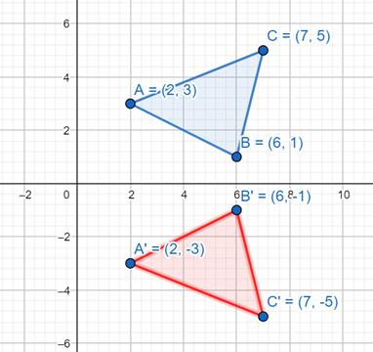
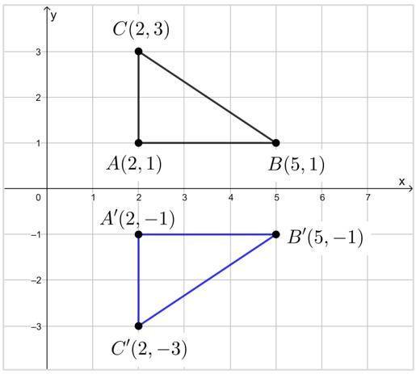
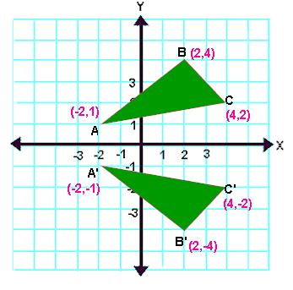
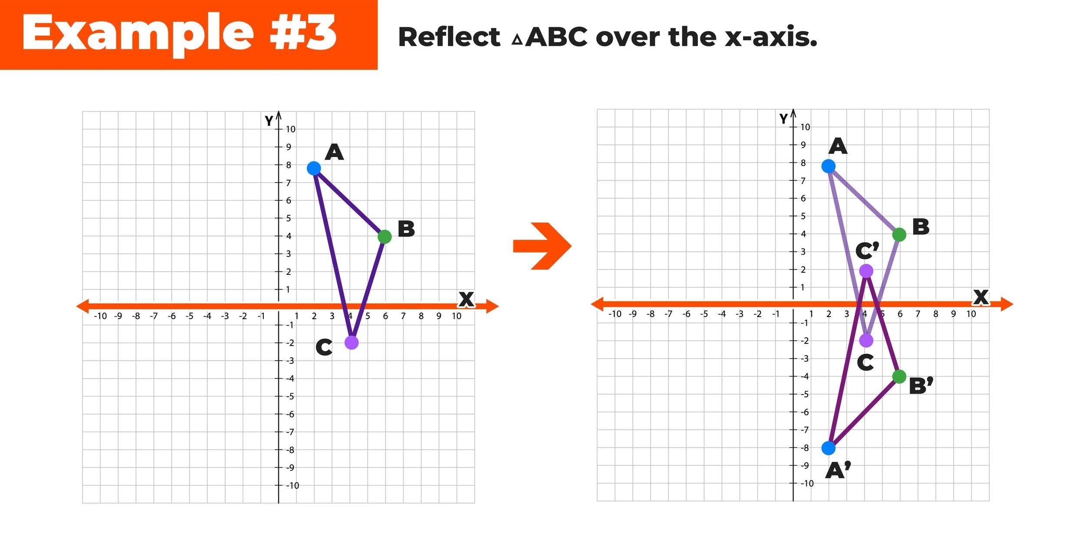
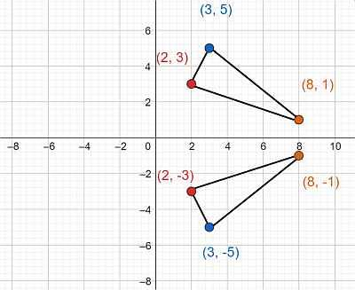

Perpendicular Relationship
# Source: AI Source: Provided by: [Data Path: Persons Table -> ID Column: 1, Name_En Column: Motasem Essam] -> From: [ChatGPT] on [7/25/2026]
For any point $A$ and its reflected image $A^{'}$:
$$\boxed{AA^{'}⊥l}$$
where $l$ is the line of reflection.
This means the segment joining a point to its image is perpendicular to the reflection line.
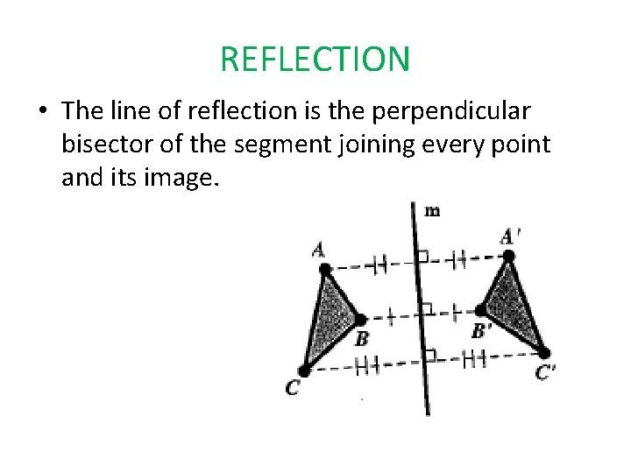
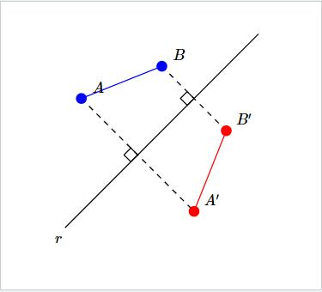
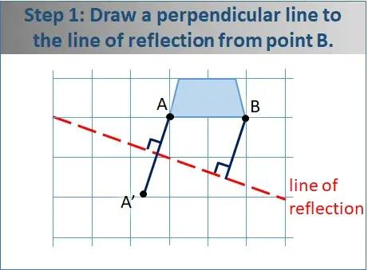
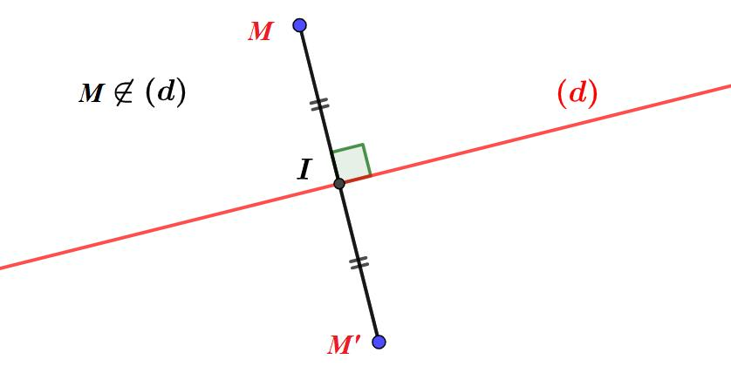

Equal Distance Property
# Source: AI Source: Provided by: [Data Path: Persons Table -> ID Column: 1, Name_En Column: Motasem Essam] -> From: [ChatGPT] on [7/25/2026]
The point and its image have equal distances from the reflection line.
$$\boxed{d\left(A , l\right)=d\left(A^{'} , l\right)}$$
For example, if $A$ is $4$ units from the reflection line, then $A^{'}$ is also $4$ units from it.

Midpoint Property
# Source: AI Source: Provided by: [Data Path: Persons Table -> ID Column: 1, Name_En Column: Motasem Essam] -> From: [ChatGPT] on [7/25/2026]
The line of reflection passes through the midpoint of the segment connecting a point and its image.
If $M$ is the midpoint of $AA^{'}$, then:
$$\boxed{M∈l}$$
Therefore, the reflection line is the perpendicular bisector of $AA^{'}$.

Reflection Preserves Distance
# Source: AI Source: Provided by: [Data Path: Persons Table -> ID Column: 1, Name_En Column: Motasem Essam] -> From: [ChatGPT] on [7/25/2026]
Reflection preserves distances between corresponding points.
If:
$$AB=6$$
then:
$$\boxed{A^{'}B^{'}=6}$$
Therefore:
$$\boxed{AB=A^{'}B^{'}}$$

Reflection Preserves Angles
# Source: AI Source: Provided by: [Data Path: Persons Table -> ID Column: 1, Name_En Column: Motasem Essam] -> From: [ChatGPT] on [7/25/2026]
Reflection preserves the measure of angles.
If:
$$∠A={60}^{∘}$$
then:
$$\boxed{∠A^{'}={60}^{∘}}$$
Thus, corresponding angles remain equal.

Reflection Preserves Shape
# Source: AI Source: Provided by: [Data Path: Persons Table -> ID Column: 1, Name_En Column: Motasem Essam] -> From: [ChatGPT] on [7/25/2026]
Reflection does not stretch or distort the figure.
$$\boxed{{\text{Shape}}_{original}={\text{Shape}}_{reflected}}$$
The reflected figure has the same geometric shape as the original.

Reflection Preserves Size
# Source: AI Source: Provided by: [Data Path: Persons Table -> ID Column: 1, Name_En Column: Motasem Essam] -> From: [ChatGPT] on [7/25/2026]
All corresponding side lengths remain unchanged.
Therefore:
$$\boxed{{\text{Size}}_{original}={\text{Size}}_{reflected}}$$
Reflection is therefore a rigid transformation.

Reflection Preserves Area
# Source: AI Source: Provided by: [Data Path: Persons Table -> ID Column: 1, Name_En Column: Motasem Essam] -> From: [ChatGPT] on [7/25/2026]
Reflection does not change the area of a figure.
If:
$$A=24$$
then:
$$\boxed{A^{'}=24}$$
Therefore:
$$\boxed{A^{'}=A}$$

Reflection Preserves Perimeter
# Source: AI Source: Provided by: [Data Path: Persons Table -> ID Column: 1, Name_En Column: Motasem Essam] -> From: [ChatGPT] on [7/25/2026]
Reflection also preserves perimeter.
If:
$$P=20$$
then:
$$\boxed{P^{'}=20}$$
Therefore:
$$\boxed{P^{'}=P}$$

Reflection Changes Orientation
# Source: AI Source: Provided by: [Data Path: Persons Table -> ID Column: 1, Name_En Column: Motasem Essam] -> From: [ChatGPT] on [7/25/2026]
Reflection reverses the orientation of a figure.
For example, if the vertices of a triangle are labeled in a clockwise order, their corresponding reflected vertices appear in the opposite order.
This is one important difference between reflection and rotation.
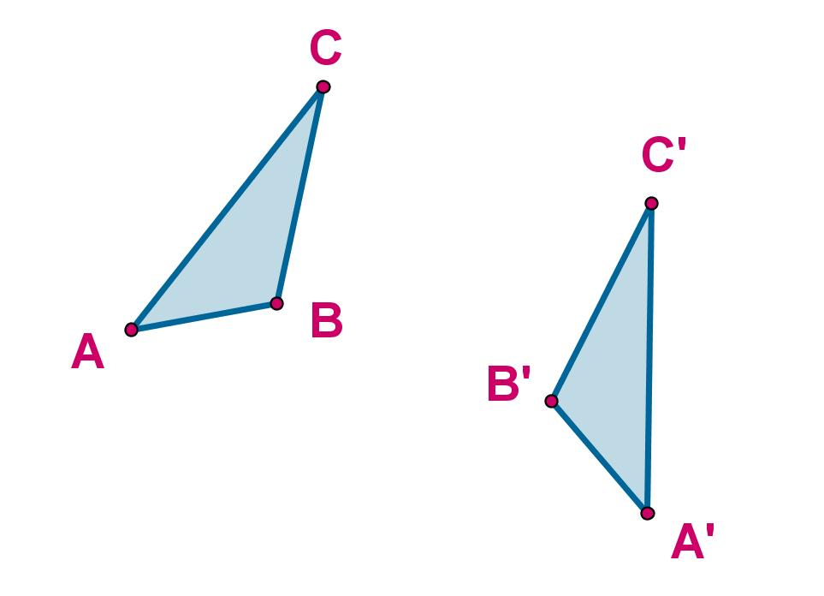
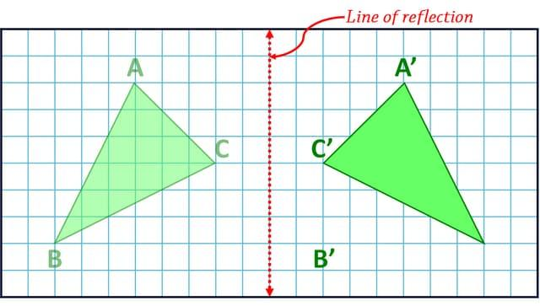
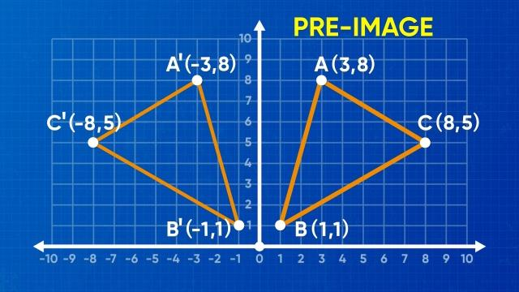
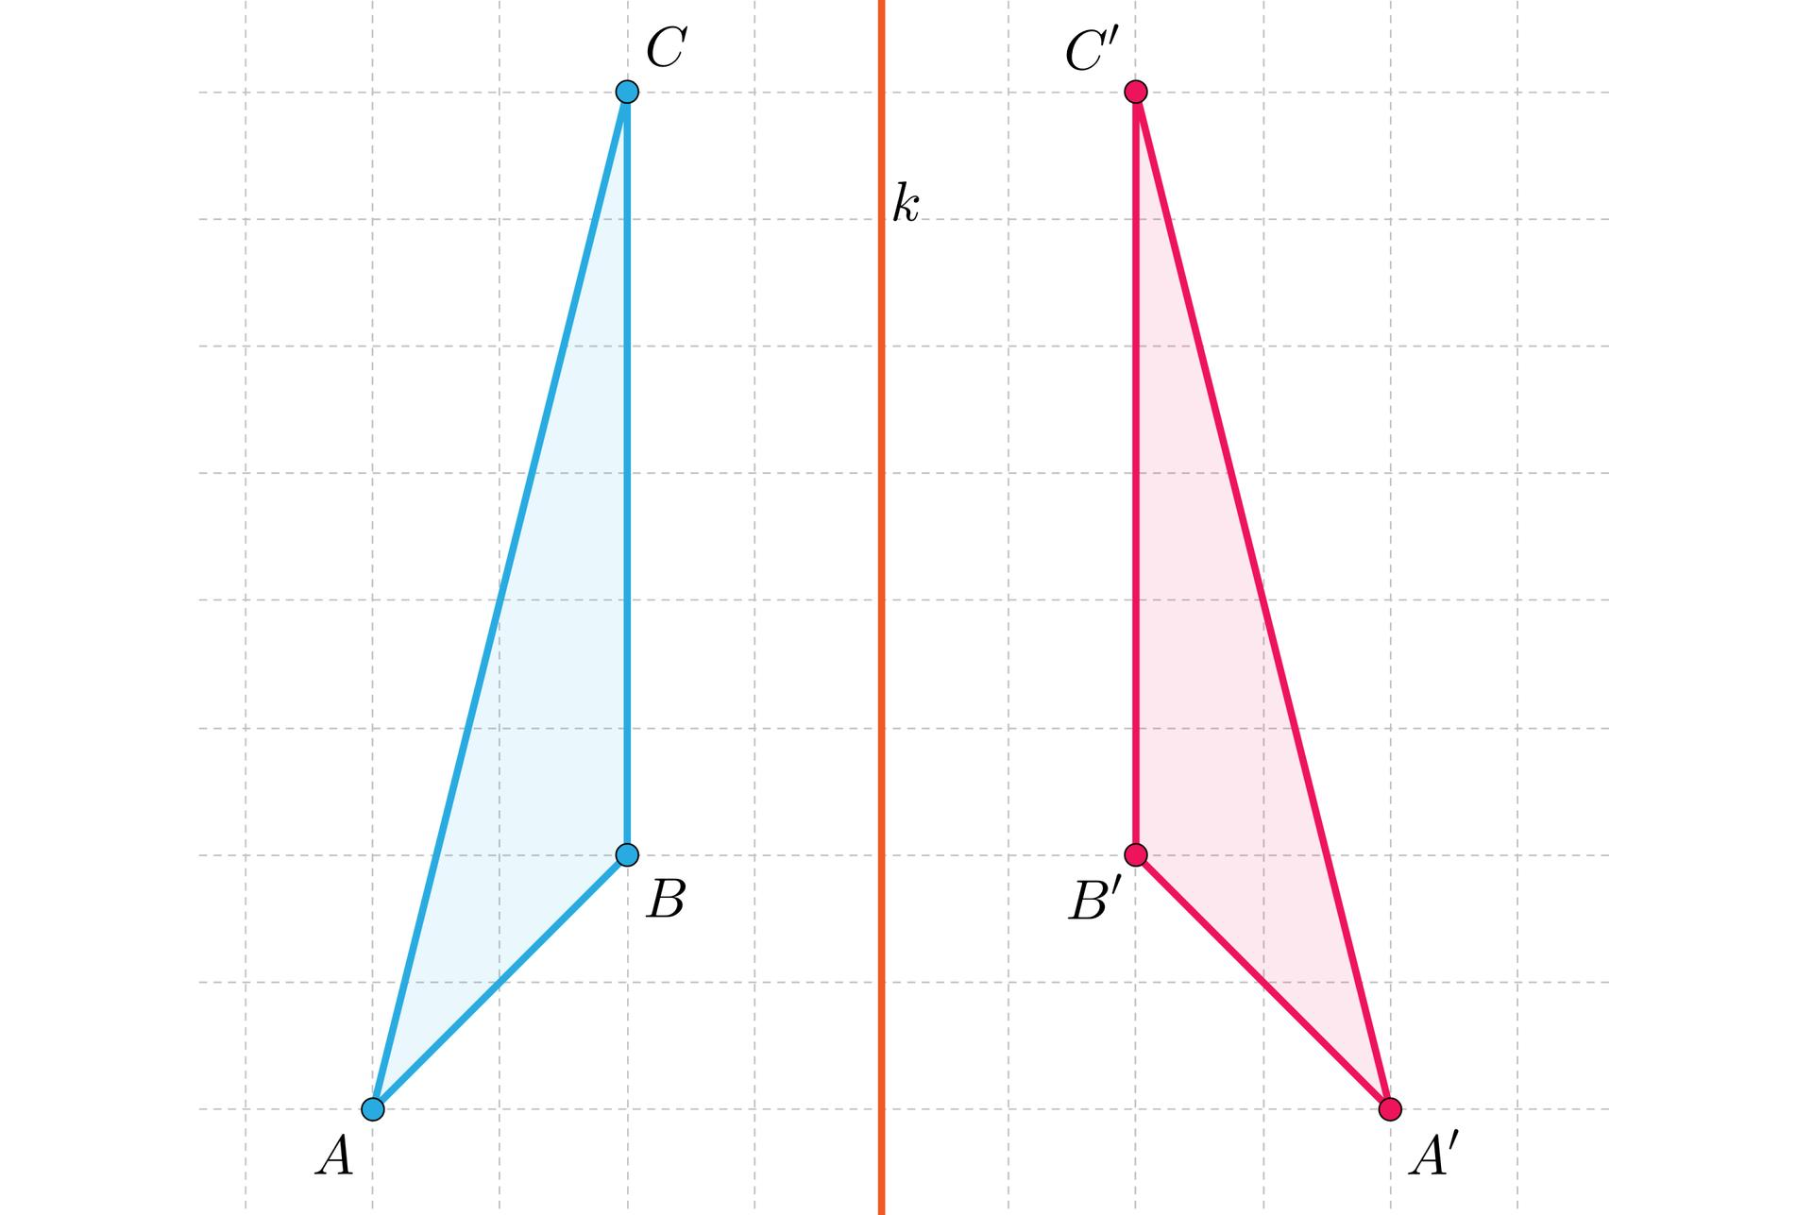
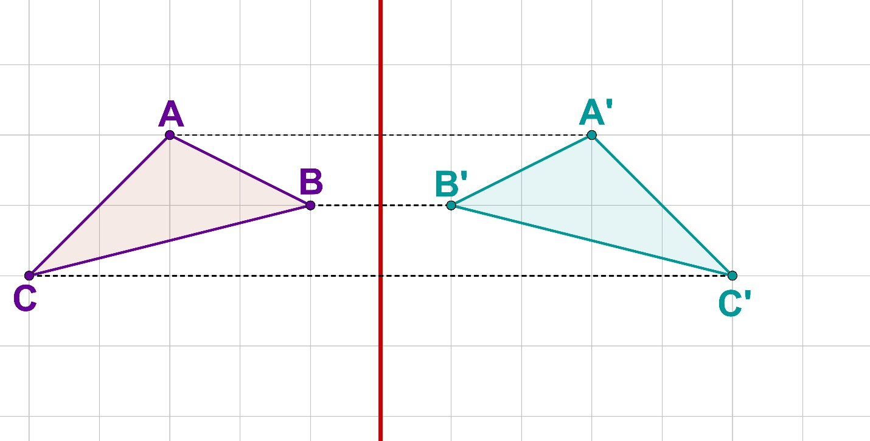

Reflection and Congruence
# Source: AI Source: Provided by: [Data Path: Persons Table -> ID Column: 1, Name_En Column: Motasem Essam] -> From: [ChatGPT] on [7/25/2026]
Reflection preserves:
- Side lengths
- Angles
- Shape
- Size
- Area
- Perimeter
Therefore, the original and reflected figures are congruent:
$$\boxed{F≅F^{'}}$$

Reflection and Symmetry
# Source: AI Source: Provided by: [Data Path: Persons Table -> ID Column: 1, Name_En Column: Motasem Essam] -> From: [ChatGPT] on [7/25/2026]
Reflection is directly related to line symmetry.
A figure has line symmetry if one half of the figure is the reflection of the other half across a line.
That line is called the line of symmetry.
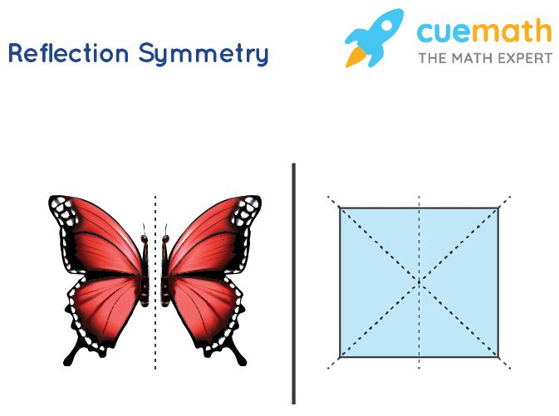
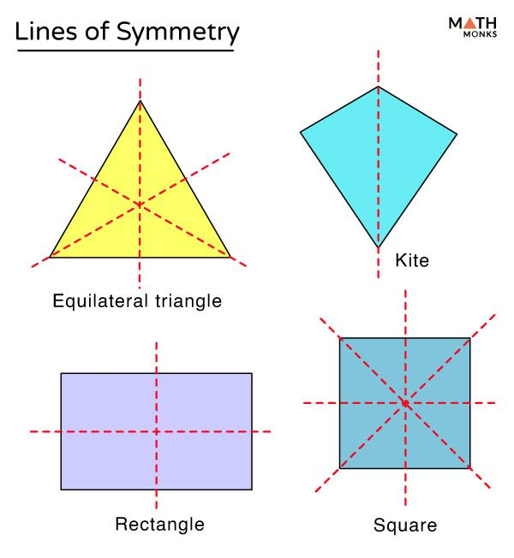
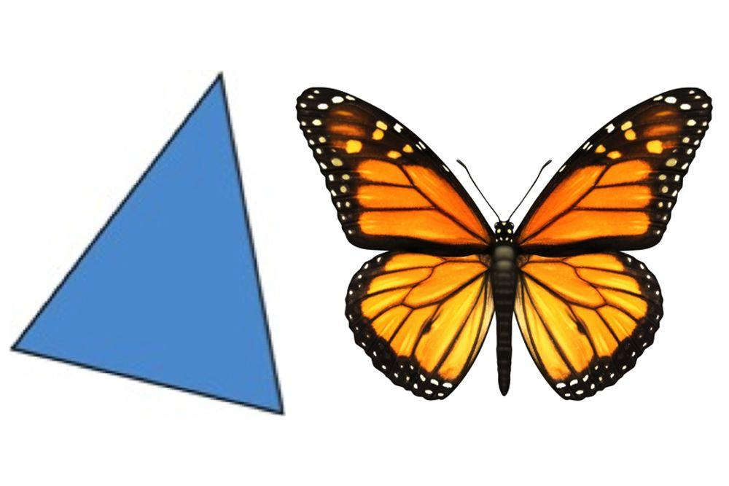
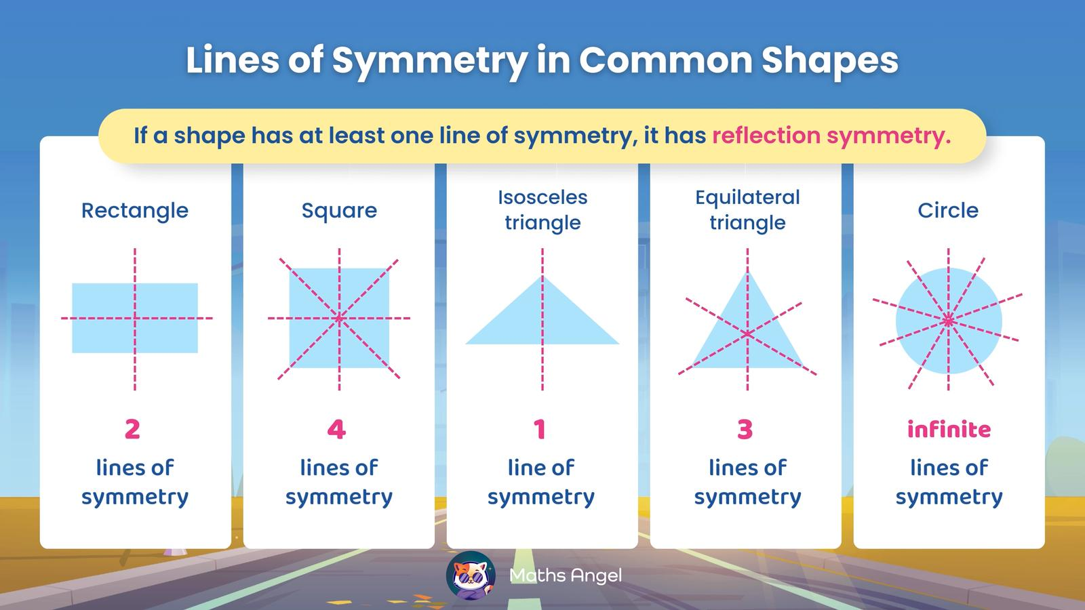
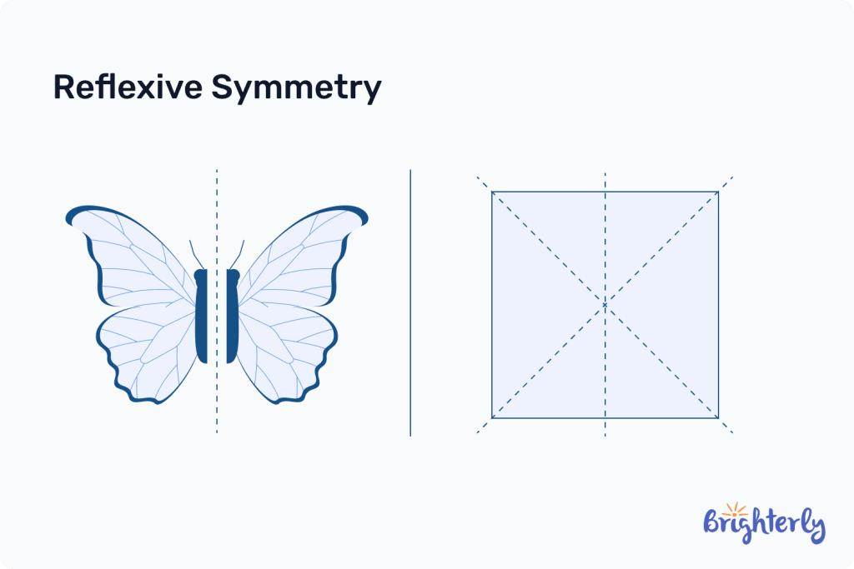
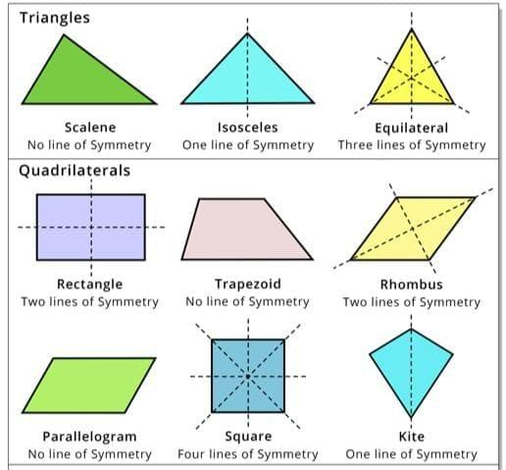

Line of Symmetry
# Source: AI Source: Provided by: [Data Path: Persons Table -> ID Column: 1, Name_En Column: Motasem Essam] -> From: [ChatGPT] on [7/25/2026]
A line of symmetry divides a figure into two mirror-image halves.
For example, a square has four lines of symmetry.
$$\boxed{\text{Number of lines of symmetry}=4}$$
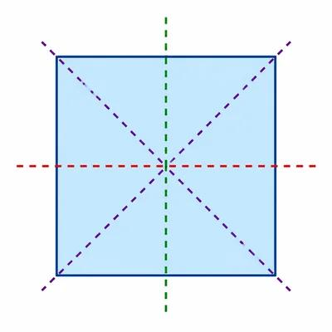
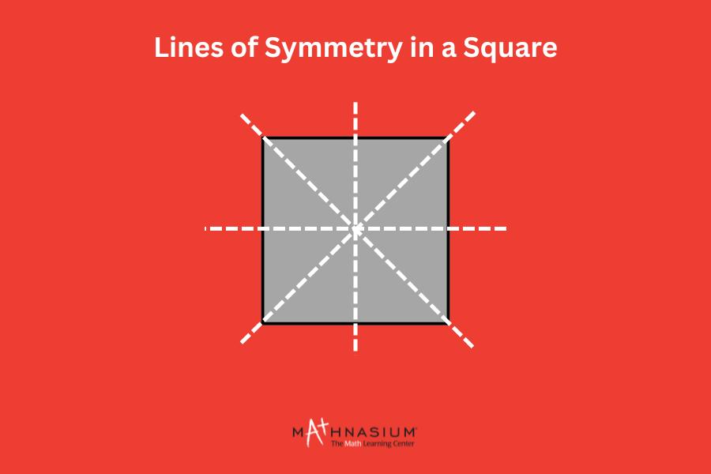
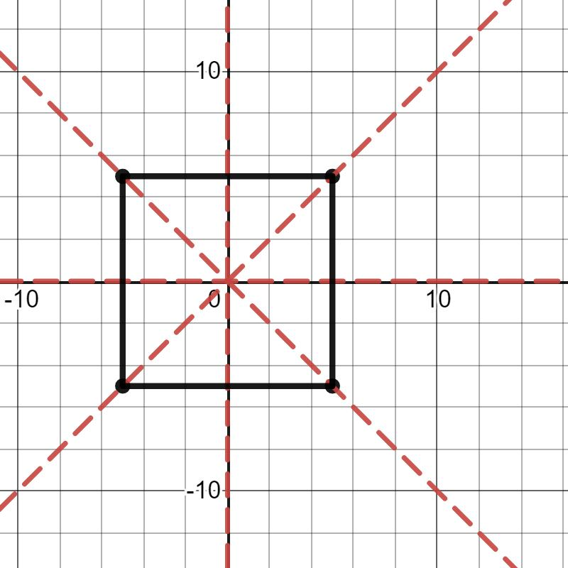
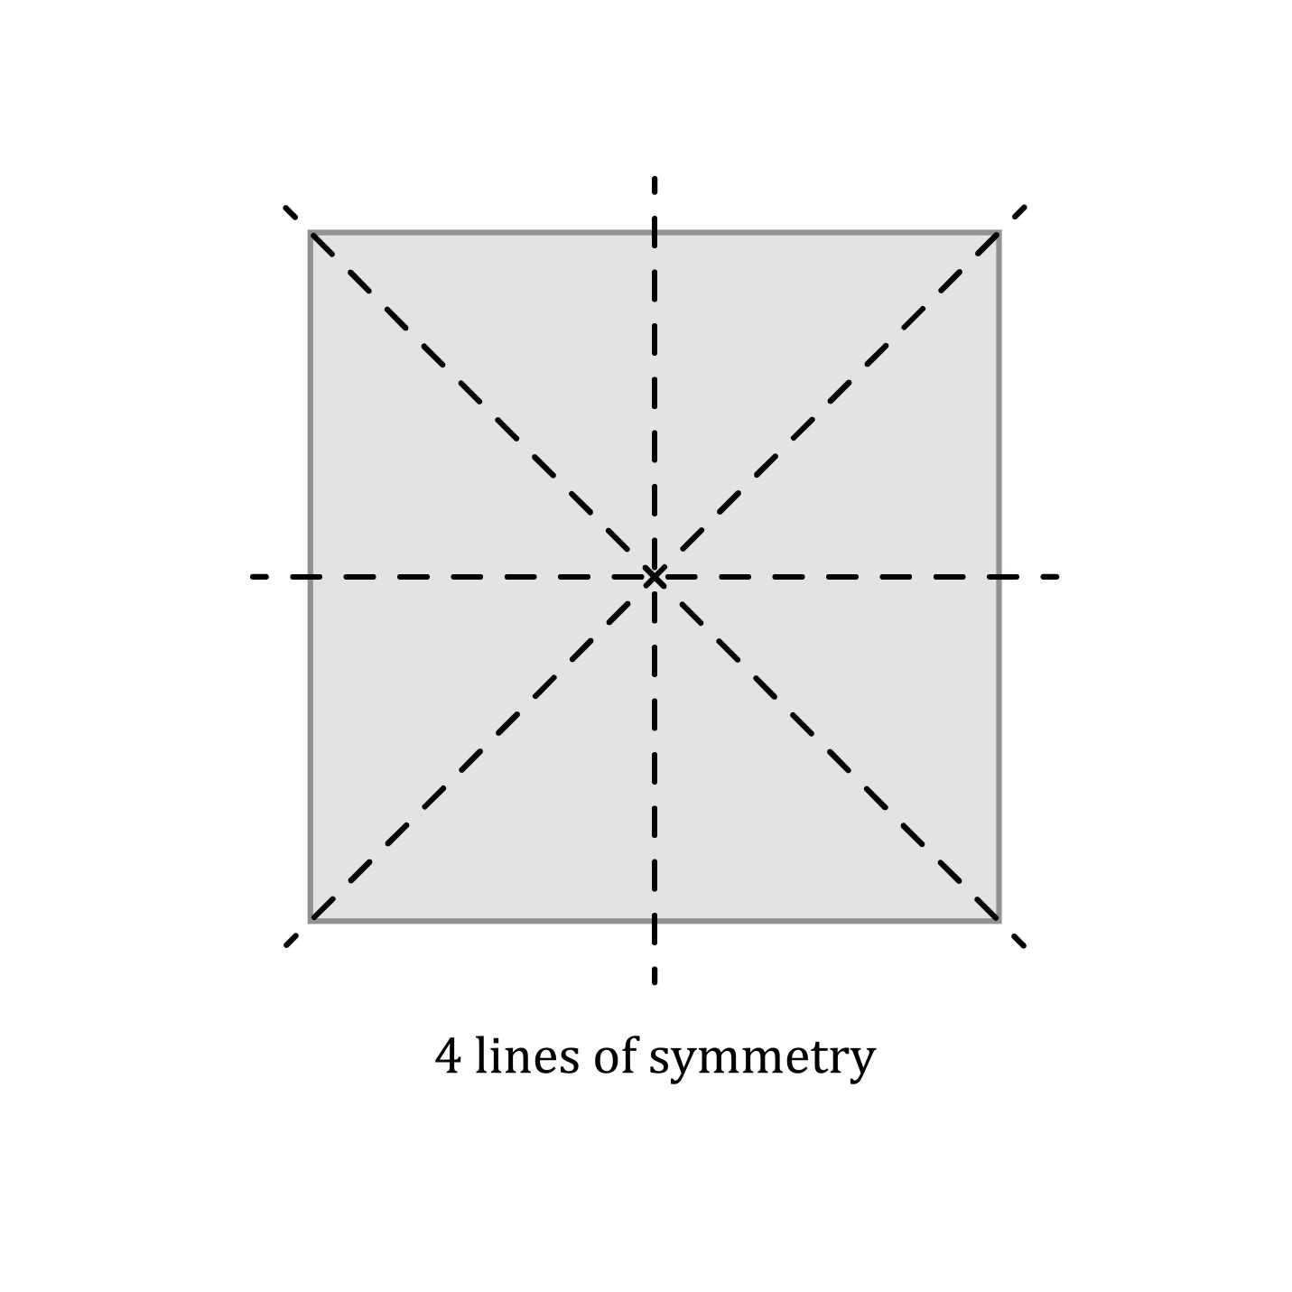

Reflection vs Line Symmetry
# Source: AI Source: Provided by: [Data Path: Persons Table -> ID Column: 1, Name_En Column: Motasem Essam] -> From: [ChatGPT] on [7/25/2026]
These concepts are related but not identical.
Reflection
A transformation that moves a figure across a line.
Line Symmetry
A property of a figure where one half is the mirror image of the other half.
Therefore:
$$\boxed{\text{Reflection is a transformation}}$$
while:
$$\boxed{\text{Line symmetry is a geometric property}}$$

Reflection of a Circle
# Source: AI Source: Provided by: [Data Path: Persons Table -> ID Column: 1, Name_En Column: Motasem Essam] -> From: [ChatGPT] on [7/25/2026]
A circle reflected across a line remains a circle with the same radius.
If:
$$r=5$$
then after reflection:
$$\boxed{r^{'}=5}$$
The center of the circle is reflected to the corresponding location.
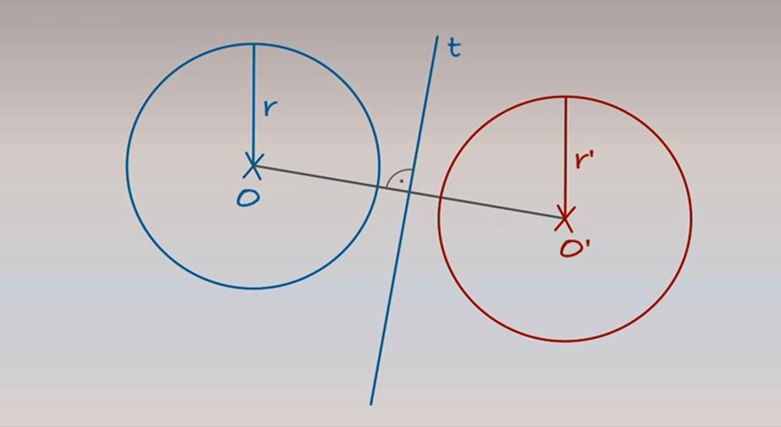
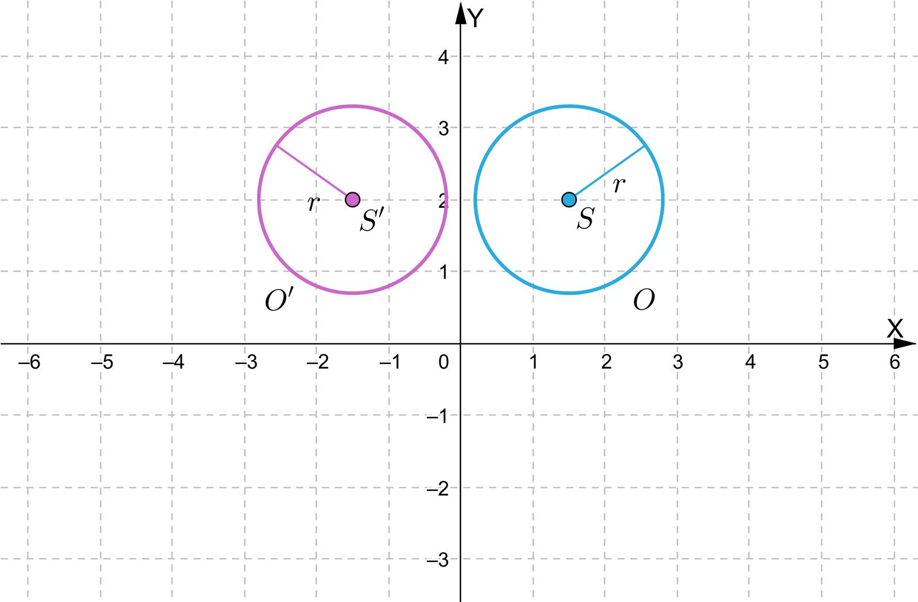
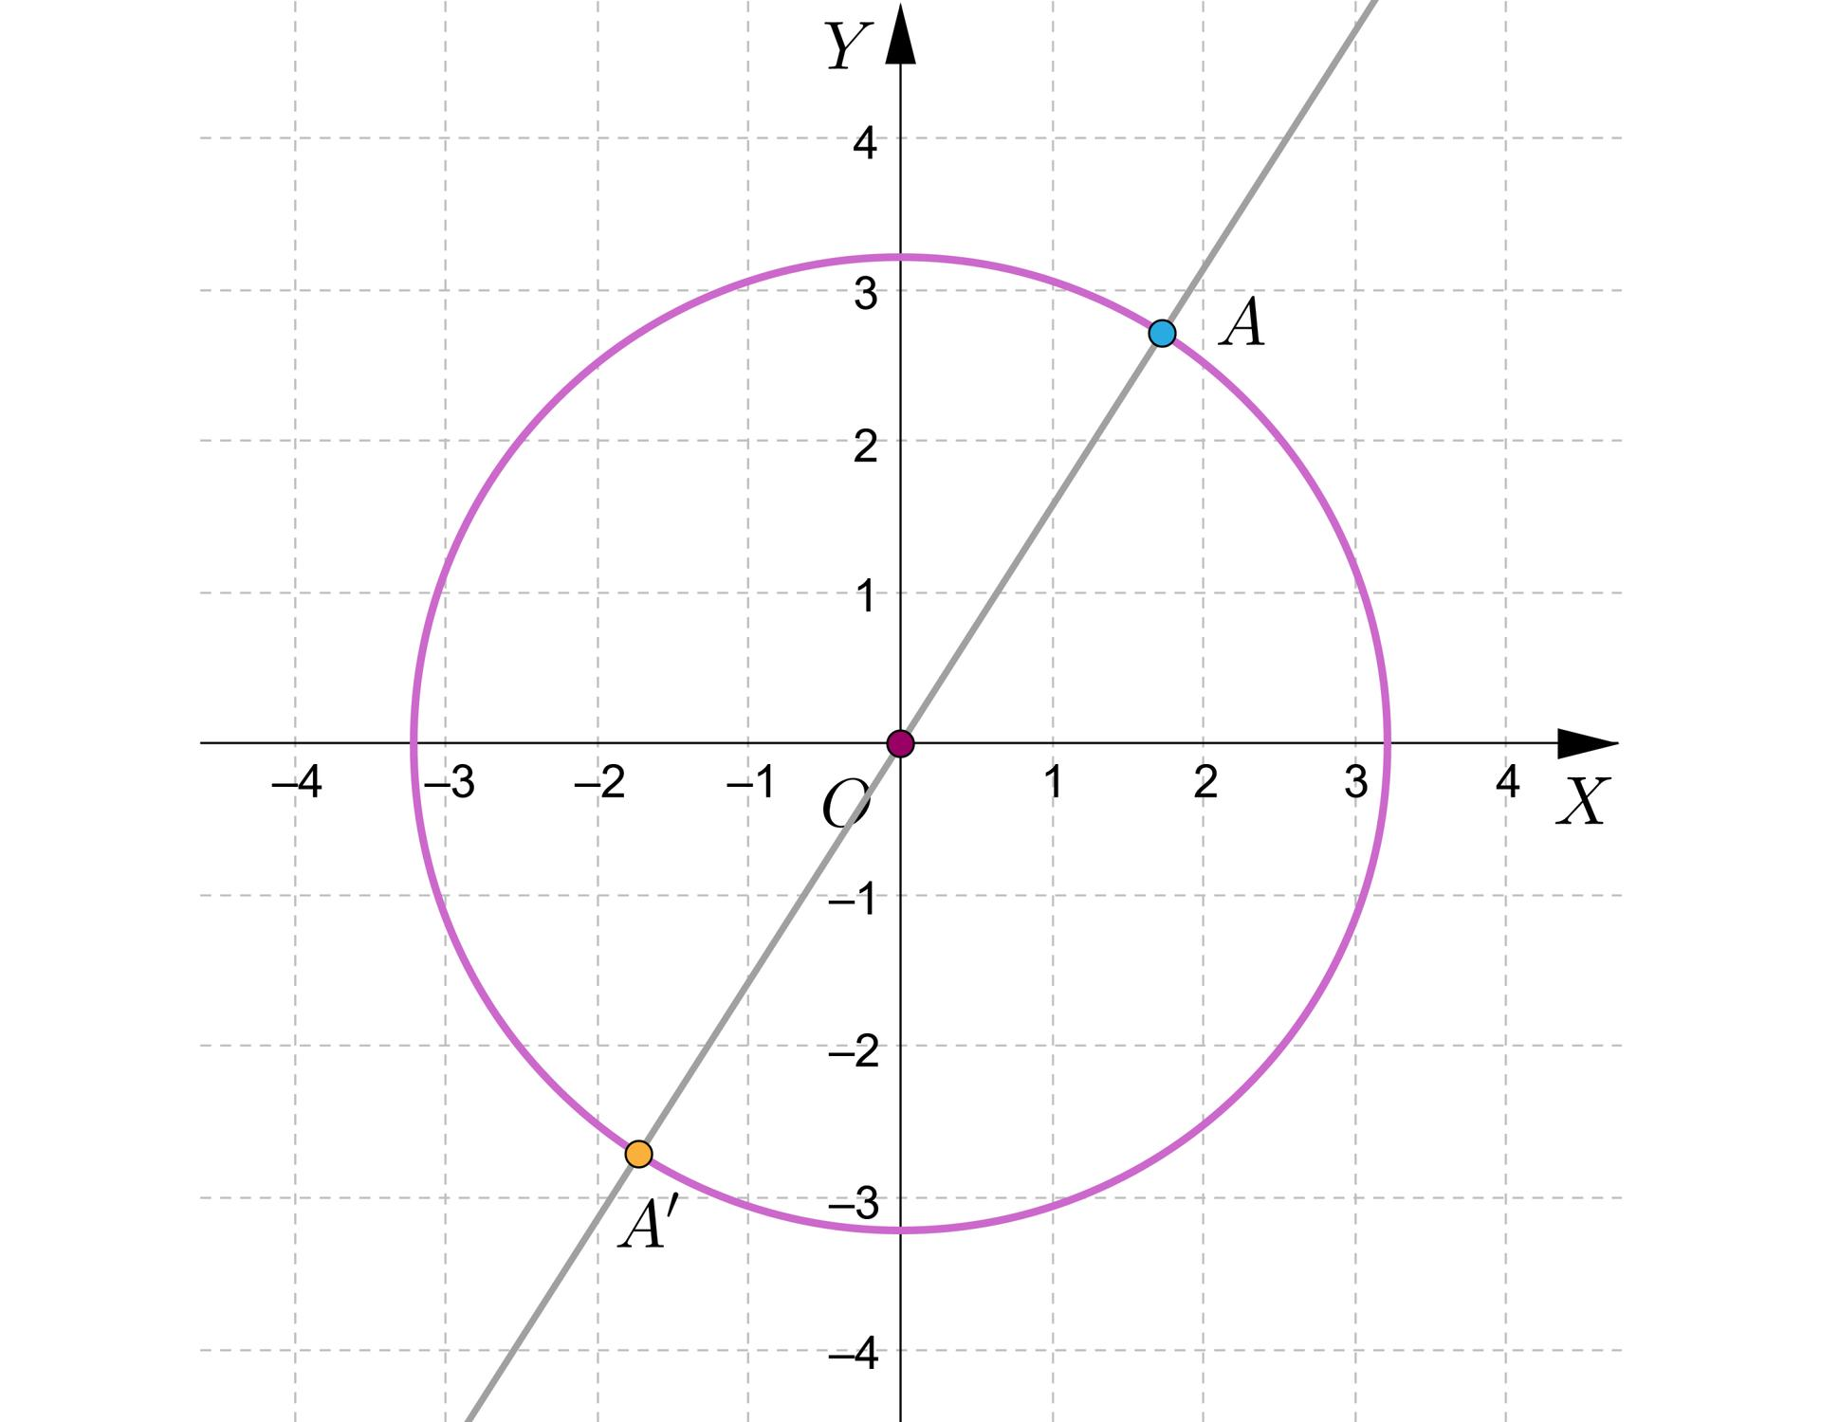
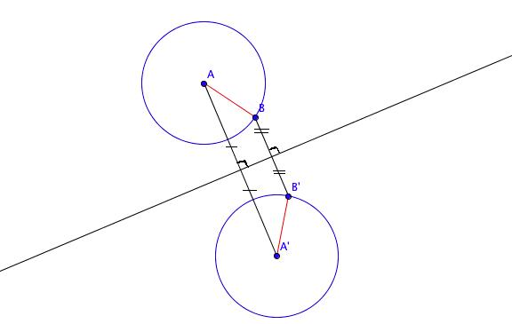
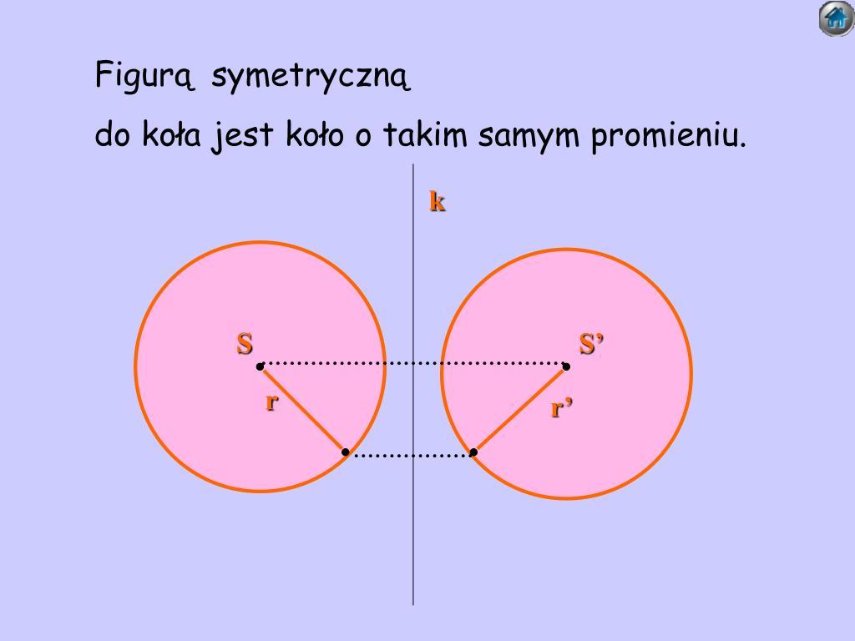
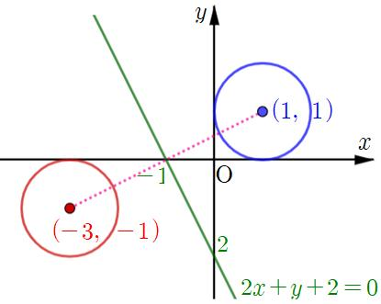

Reflection of a Polygon
# Source: AI Source: Provided by: [Data Path: Persons Table -> ID Column: 1, Name_En Column: Motasem Essam] -> From: [ChatGPT] on [7/25/2026]
Every vertex of a polygon is reflected across the same line.
If:
$$P_{i}=\left(x_{i} , y_{i}\right)$$
then its image depends on the reflection line.
For example, across the $x$-axis:
$$\boxed{P_{i}^{'}=\left(x_{i} , -y_{i}\right)}$$
All vertices are transformed using the same rule.

Composition of Reflections
# Source: AI Source: Provided by: [Data Path: Persons Table -> ID Column: 1, Name_En Column: Motasem Essam] -> From: [ChatGPT] on [7/25/2026]
Two reflections can be performed one after another.

The result depends on the relationship between the two reflection lines.
Parallel reflection lines
Two reflections across parallel lines produce a translation.
Intersecting reflection lines
Two reflections across intersecting lines produce a rotation.
This creates an important relationship between geometric transformations.

Reflection Across Two Parallel Lines
# Source: AI Source: Provided by: [Data Path: Persons Table -> ID Column: 1, Name_En Column: Motasem Essam] -> From: [ChatGPT] on [7/25/2026]
Suppose two parallel reflection lines are separated by distance $d$.
Two successive reflections produce a translation of:
$$\boxed{2d}$$
in the direction perpendicular to the reflection lines.

Reflection Across Two Intersecting Lines
# Source: AI Source: Provided by: [Data Path: Persons Table -> ID Column: 1, Name_En Column: Motasem Essam] -> From: [ChatGPT] on [7/25/2026]
If two reflection lines intersect at an angle $θ$, two successive reflections produce a rotation through:
$$\boxed{2θ}$$
around their intersection point.
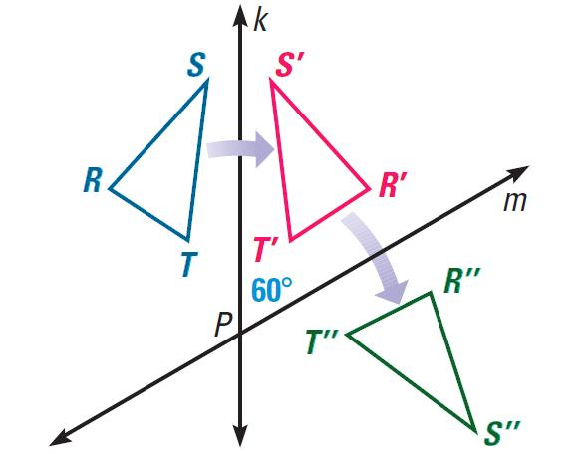
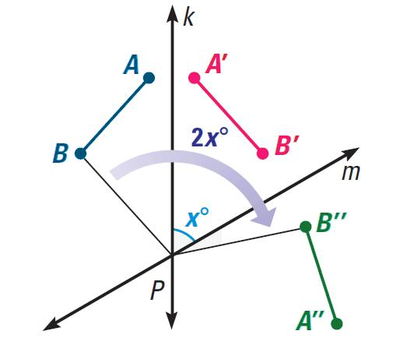
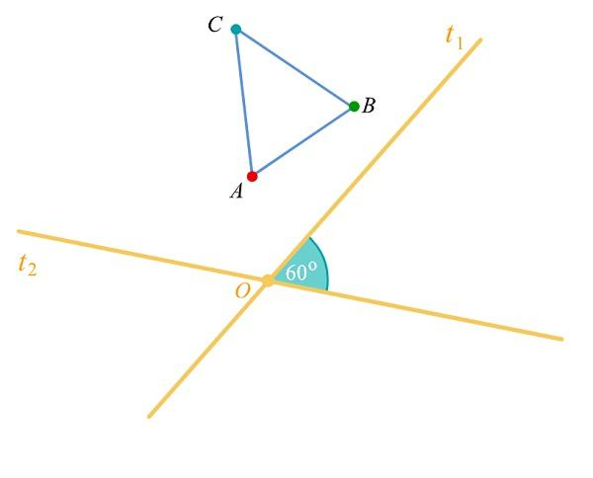

Reflection in Computer Graphics
# Source: AI Source: Provided by: [Data Path: Persons Table -> ID Column: 1, Name_En Column: Motasem Essam] -> From: [ChatGPT] on [7/25/2026]
Reflection is used in computer graphics to:
- Create mirror images.
- Flip images horizontally.
- Flip images vertically.
- Create symmetrical objects.
- Generate visual effects.
- Transform sprites and characters.
- Create reflected scenes.
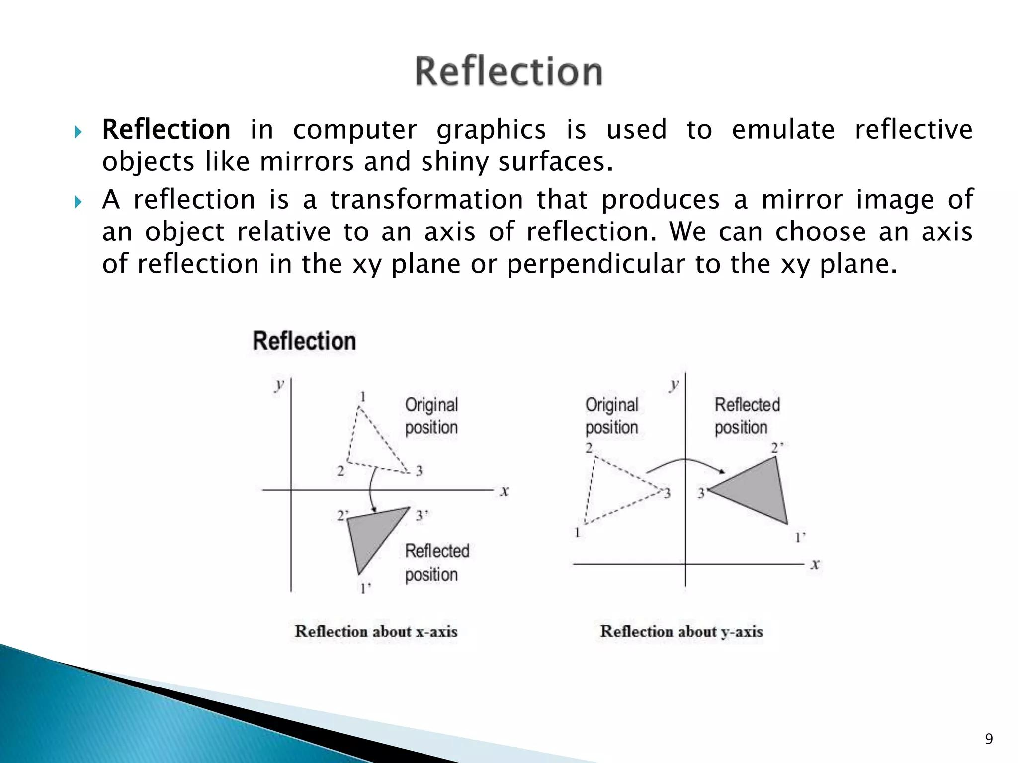
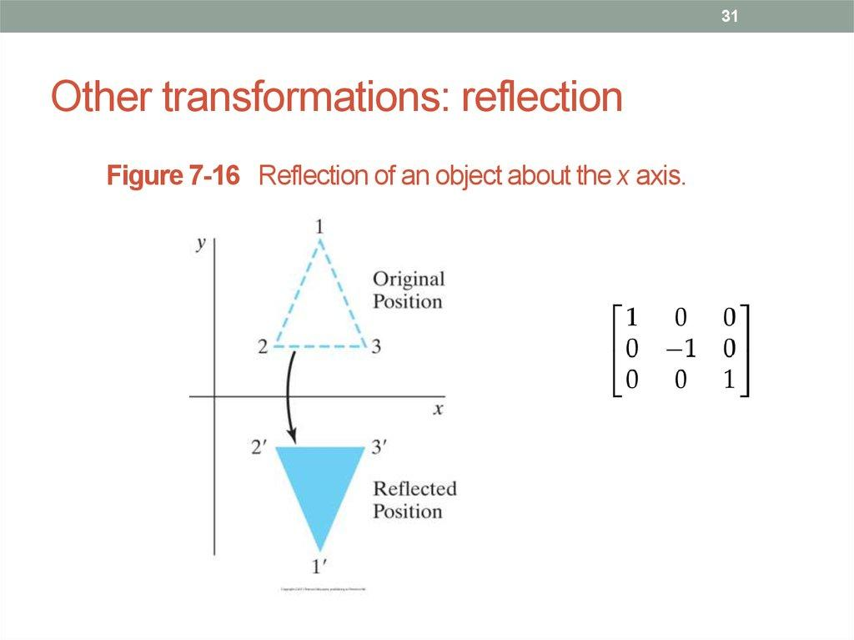
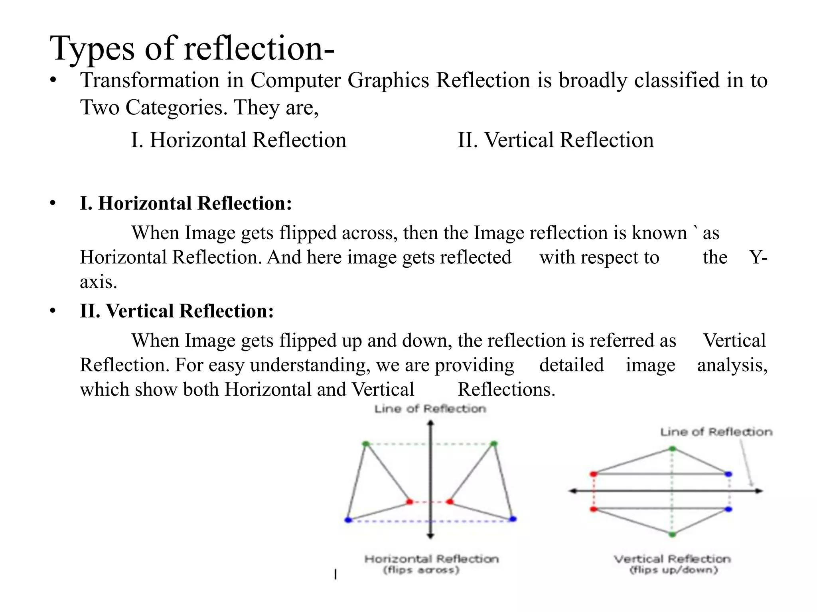
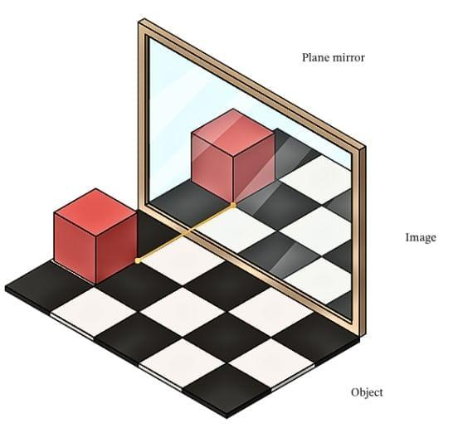
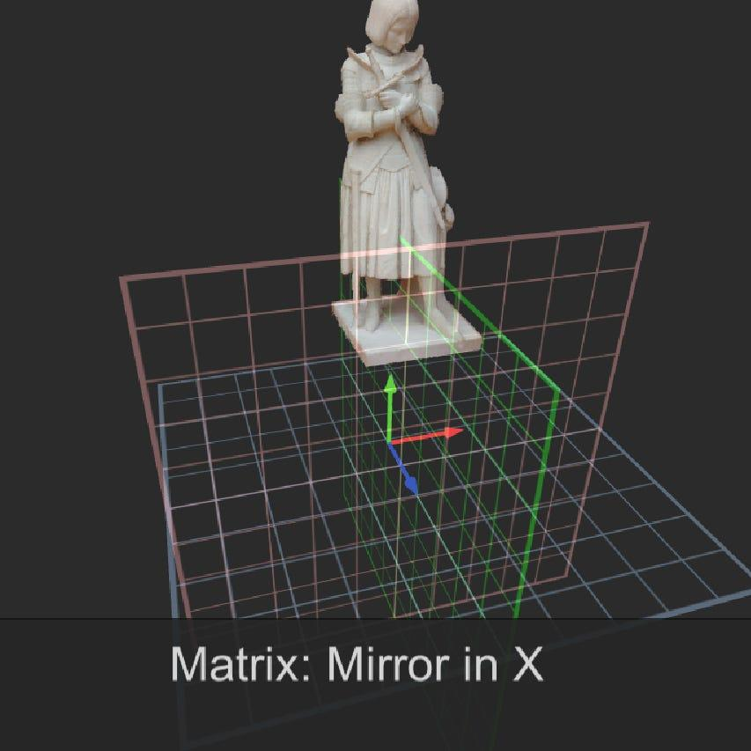

Reflection in CAD
# Source: AI Source: Provided by: [Data Path: Persons Table -> ID Column: 1, Name_En Column: Motasem Essam] -> From: [ChatGPT] on [7/25/2026]
CAD systems use reflection to create symmetrical components.
For example, a designer can:
- Create one half of a mechanical component.
- Define a reflection line.
- Reflect the component.
- Obtain the symmetrical half.
This reduces repetitive construction work.

Reflection in Architecture
# Source: AI Source: Provided by: [Data Path: Persons Table -> ID Column: 1, Name_En Column: Motasem Essam] -> From: [ChatGPT] on [7/25/2026]
Reflection is commonly used to create symmetrical architectural designs.
Examples include:
- Building facades.
- Doors and windows.
- Floor plans.
- Decorative patterns.
- Structural layouts.
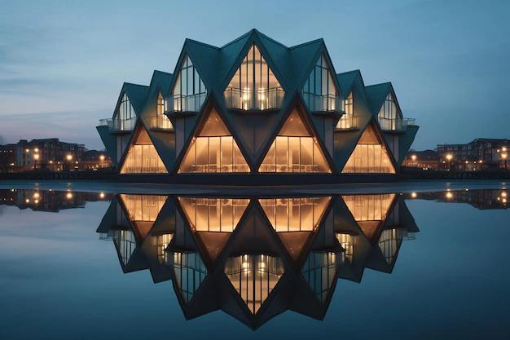
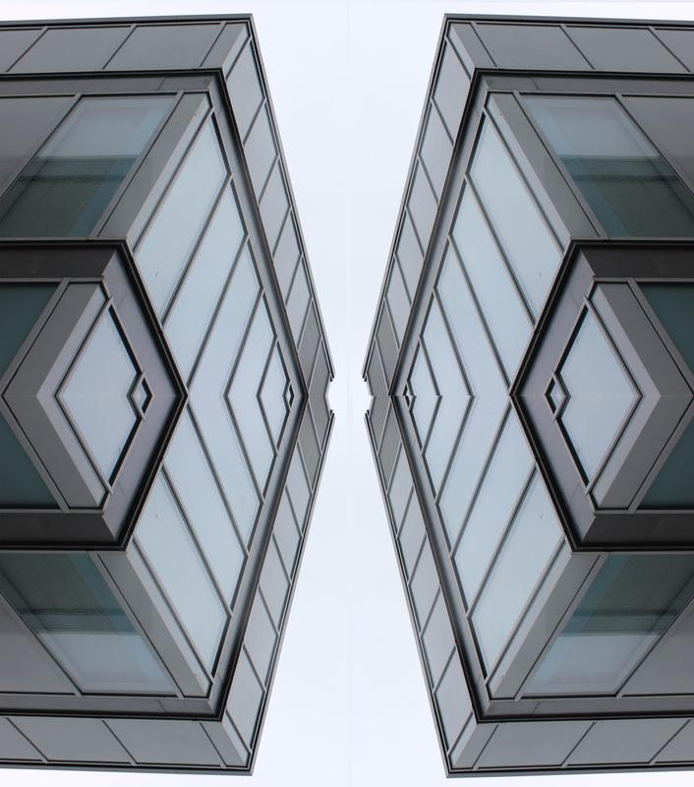
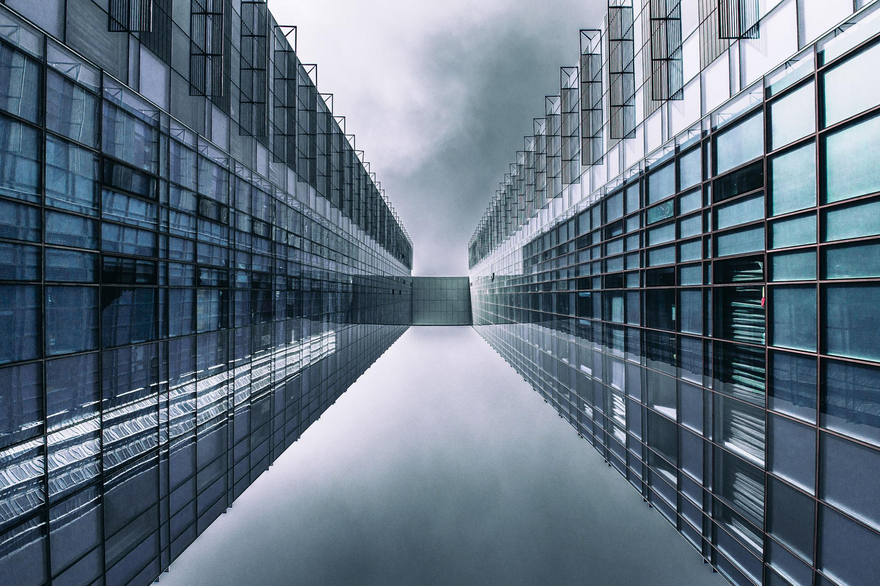
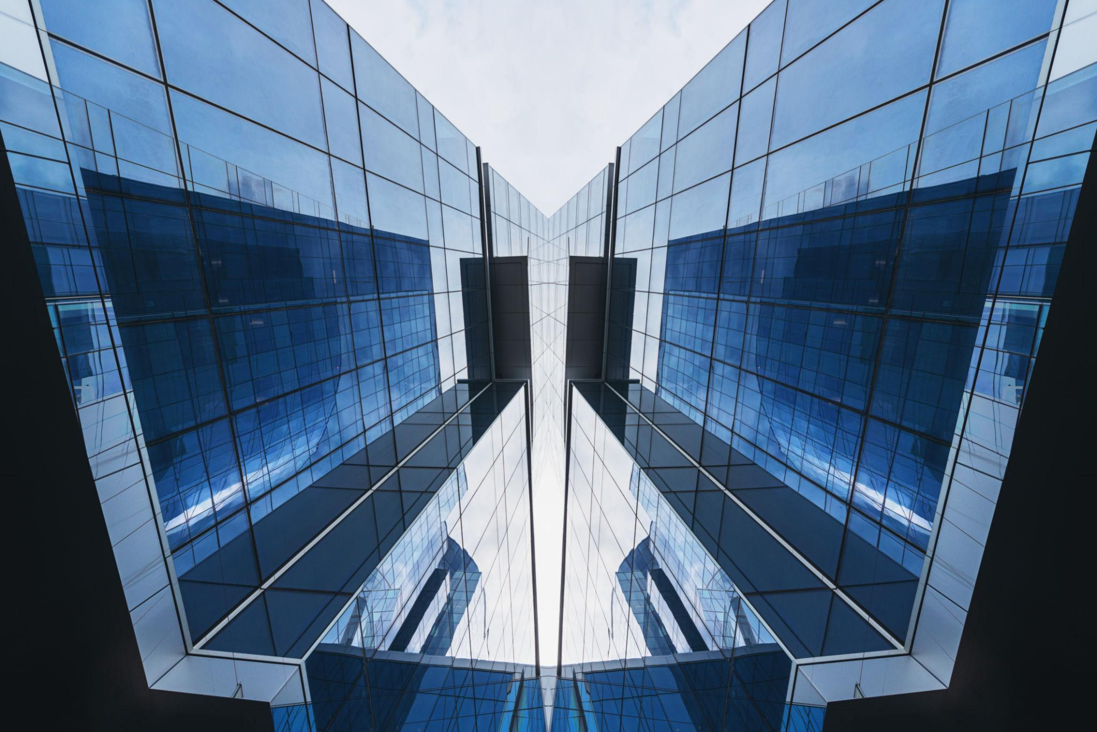
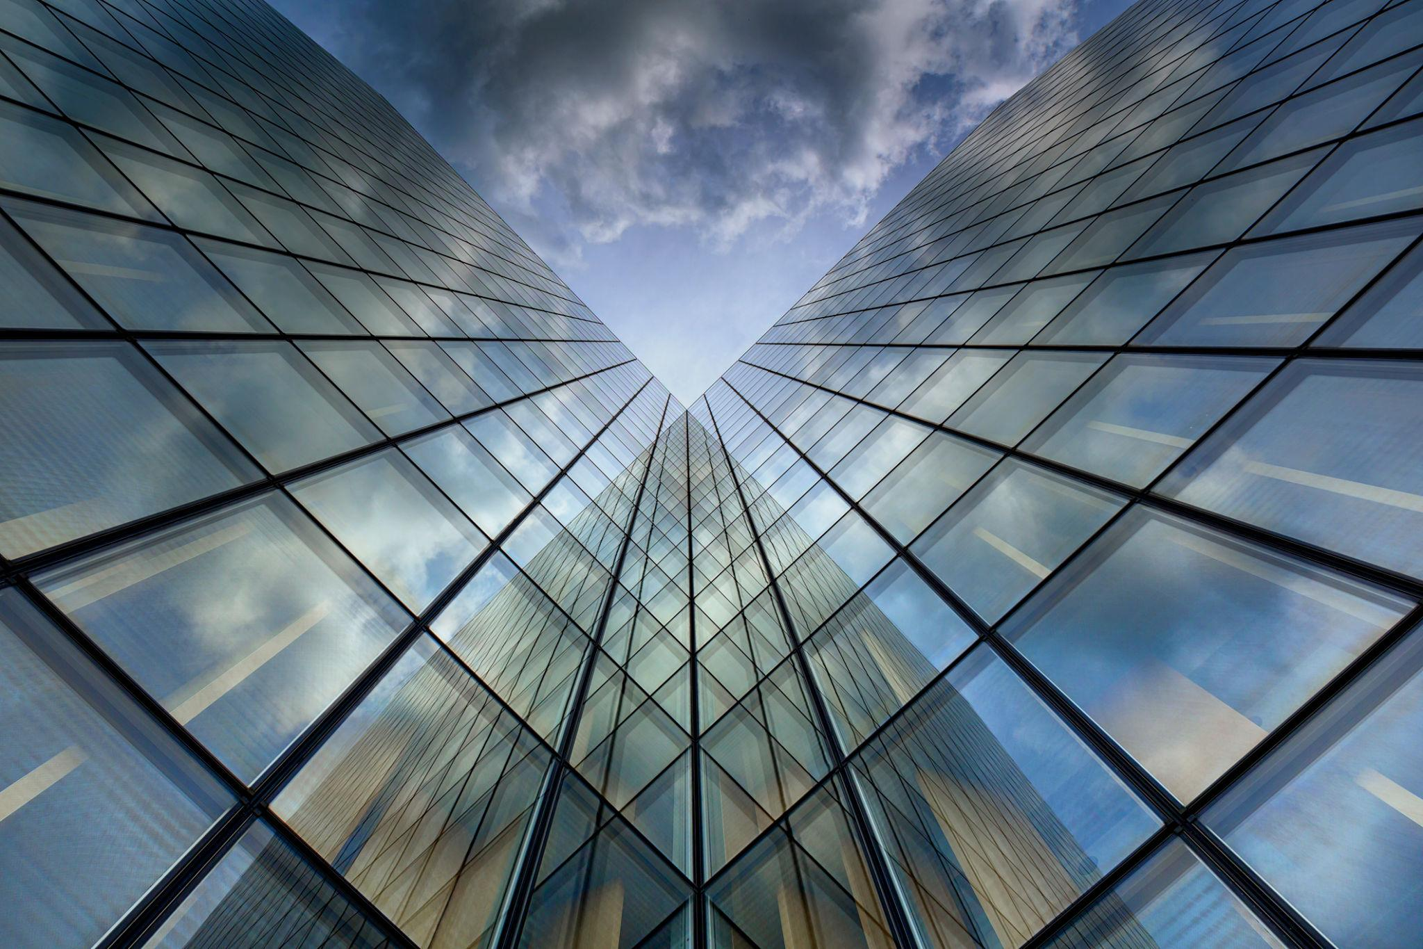
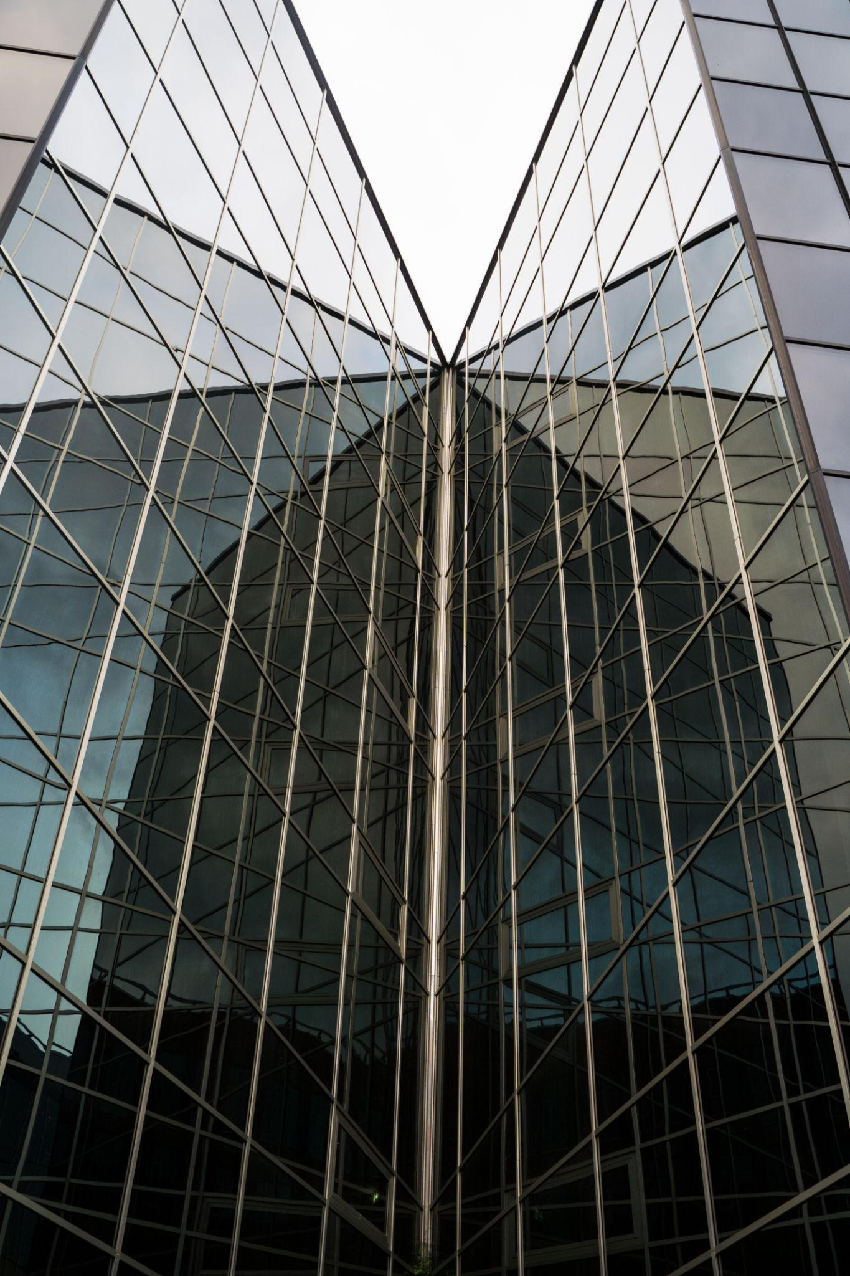

Real-World Examples
# Source: AI Source: Provided by: [Data Path: Persons Table -> ID Column: 1, Name_En Column: Motasem Essam] -> From: [ChatGPT] on [7/25/2026]
Reflection can be observed in:
- Mirrors.
- Water surfaces.
- Symmetrical buildings.
- Butterfly wings.
- Human faces.
- Road designs.
- Decorative patterns.
- Logos.
- Architectural plans.
- Computer graphics.



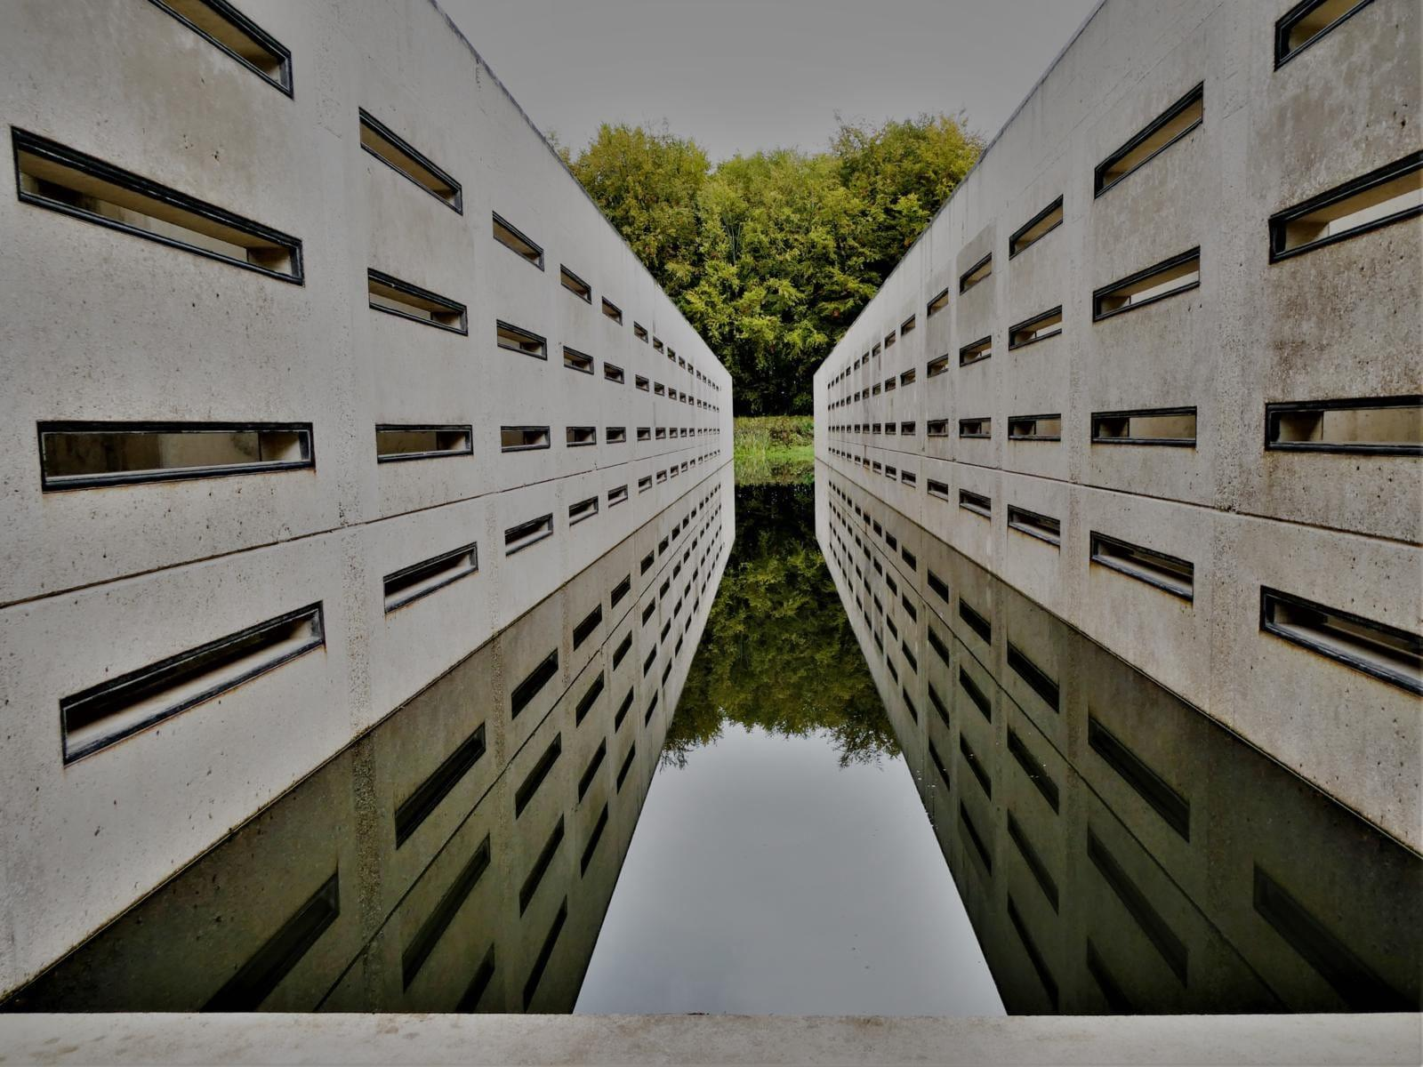

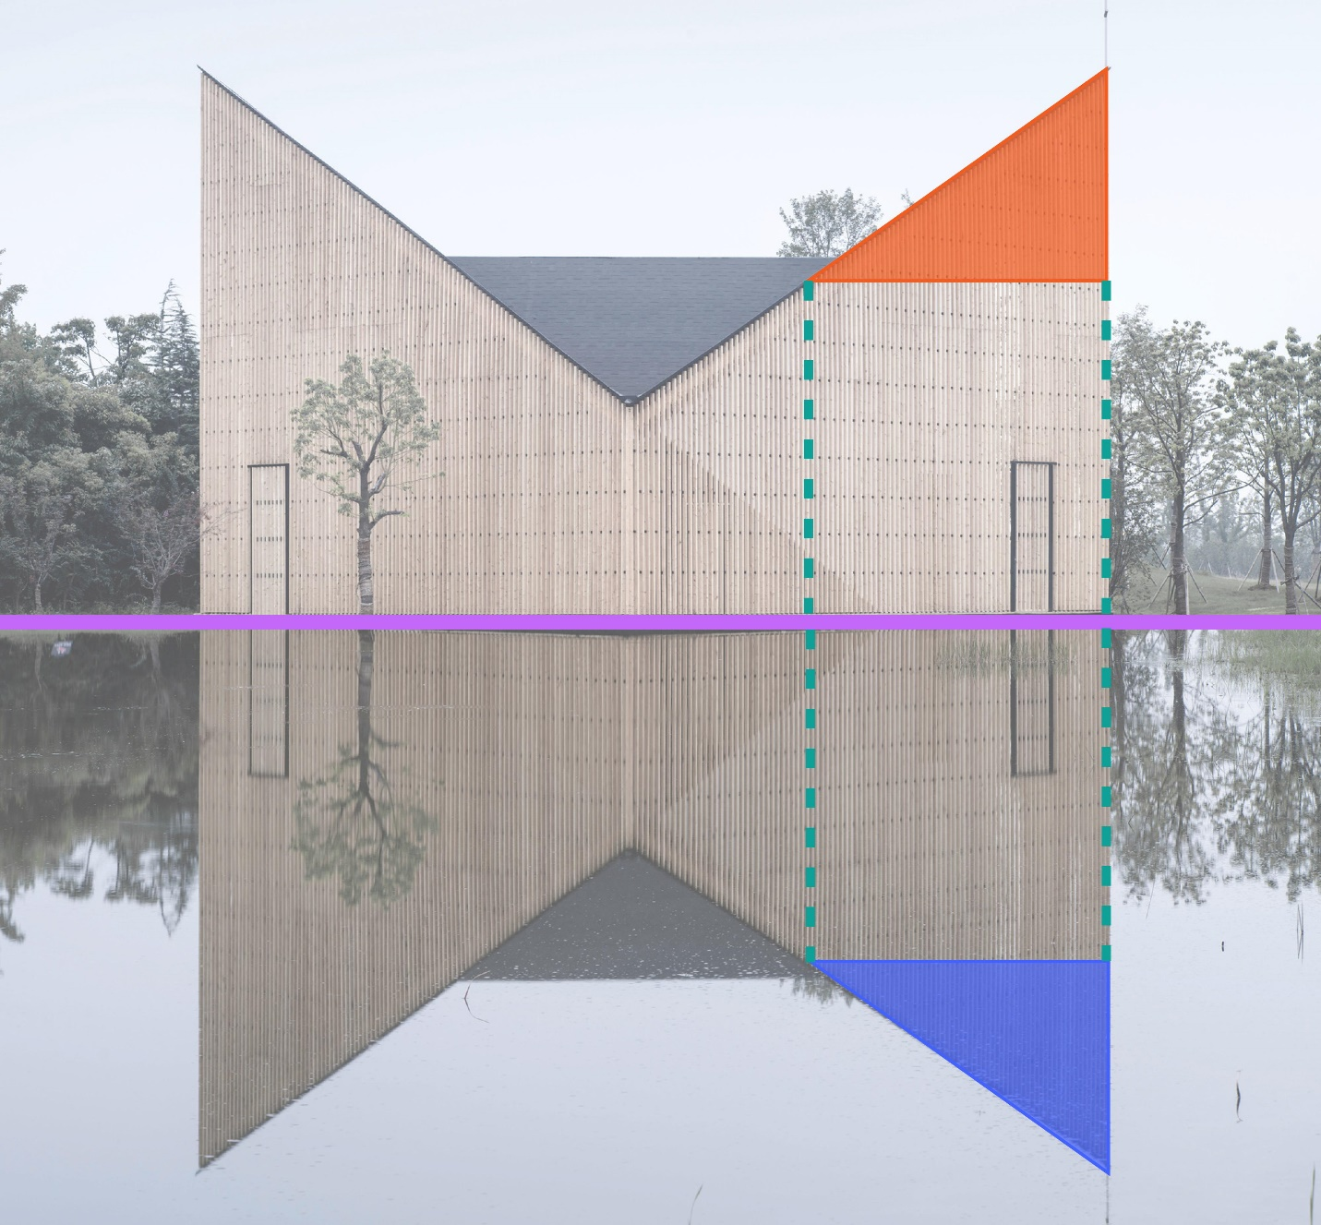

Advantages
# Source: AI Source: Provided by: [Data Path: Persons Table -> ID Column: 1, Name_En Column: Motasem Essam] -> From: [ChatGPT] on [7/25/2026]
Studying reflection helps to:
- Understand geometric transformations.
- Analyze line symmetry.
- Transform coordinate points.
- Create mirror images.
- Understand congruent figures.
- Construct symmetrical designs.
- Develop computer graphics.
- Support CAD design.
- Analyze architectural structures.

Limitations
# Source: AI Source: Provided by: [Data Path: Persons Table -> ID Column: 1, Name_En Column: Motasem Essam] -> From: [ChatGPT] on [7/25/2026]
Reflection:
- Requires a defined line of reflection.
- Changes the orientation of a figure.
- Does not change its size or shape.
- May require coordinate calculations for arbitrary reflection lines.
- Produces a mirror image rather than simply moving the figure.

Comparison with Other Transformations
# Source: AI Source: Provided by: [Data Path: Persons Table -> ID Column: 1, Name_En Column: Motasem Essam] -> From: [ChatGPT] on [7/25/2026]
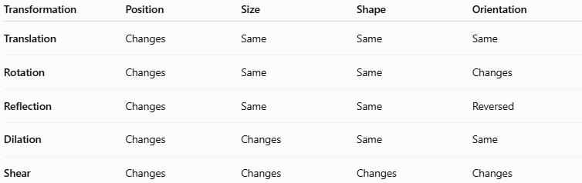
Transformation | Position | Size | Shape | Orientation
Translation | Changes | Same | Same | Same
Rotation | Changes | Same | Same | Changes
Reflection | Changes | Same | Same | Reversed
Dilation | Changes | Changes | Same | Same
Shear | Changes | Changes | Changes | Changes
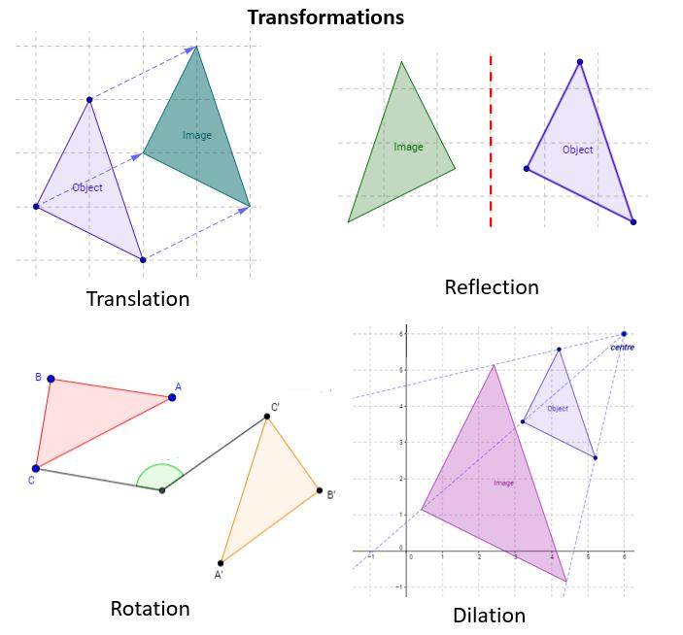
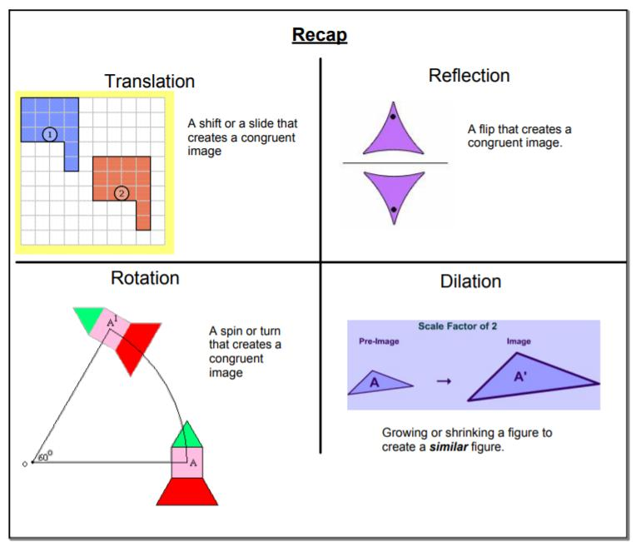
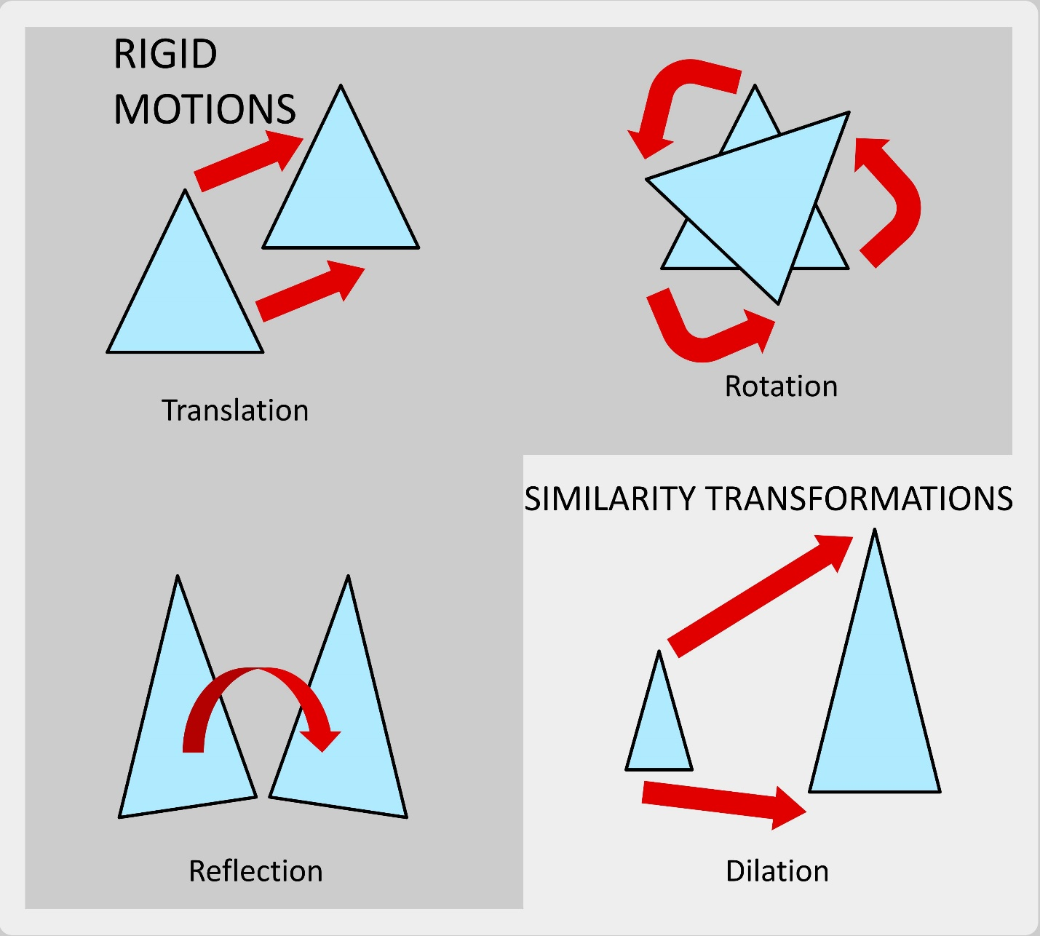
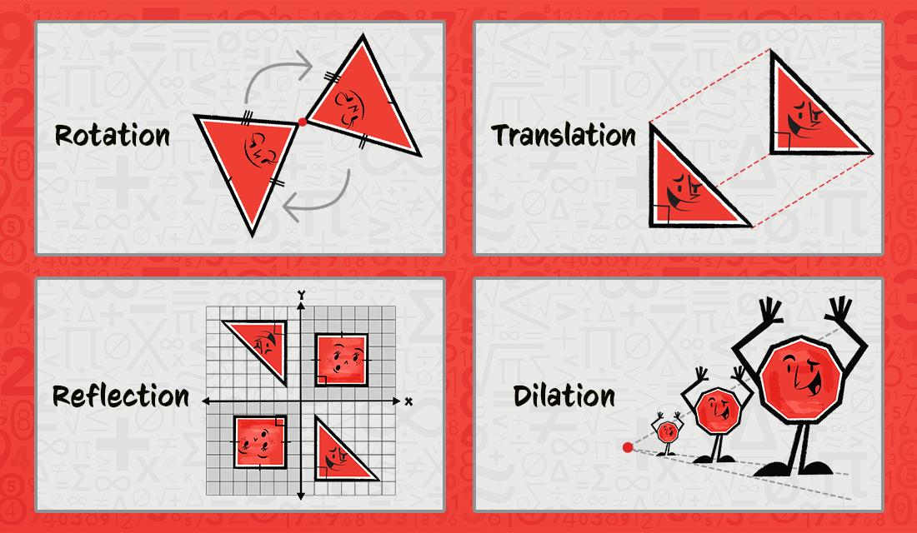
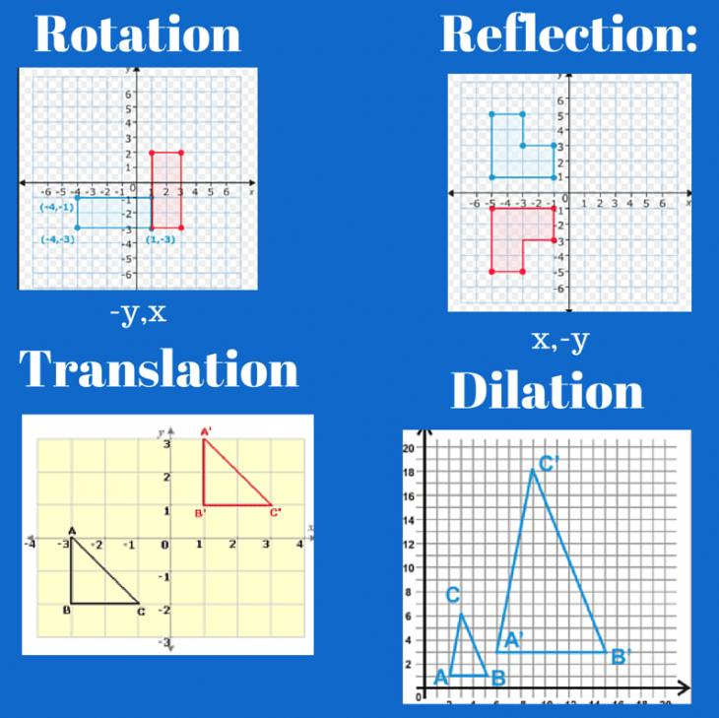

Important Coordinate Rules
# Source: AI Source: Provided by: [Data Path: Persons Table -> ID Column: 1, Name_En Column: Motasem Essam] -> From: [ChatGPT] on [7/25/2026]
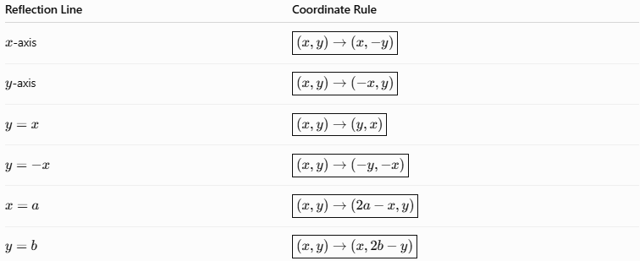
Reflection Line | Coordinate Rule
$x$-axis | $$\boxed{\left(x , y\right)→\left(x , -y\right)}$$
$y$-axis | $$\boxed{\left(x , y\right)→\left(- , xy\right)}$$
$$y=x$$ | $$\boxed{\left(x , y\right)→\left(y , x\right)}$$
$$y=-x$$ | $$\boxed{\left(x , y\right)→\left(- , y-x\right)}$$
$$x=a$$ | $$\boxed{\left(x , y\right)→\left(2 , a-xy\right)}$$
$$y=b$$ | $$\boxed{\left(x , y\right)→\left(x , 2b-y\right)}$$

Key Points
# Source: AI Source: Provided by: [Data Path: Persons Table -> ID Column: 1, Name_En Column: Motasem Essam] -> From: [ChatGPT] on [7/25/2026]
- Reflection creates a mirror image of a figure.
- The fixed line is called the line of reflection.
- Each point and its image are equally distant from the reflection line.
- The segment connecting a point to its image is perpendicular to the reflection line:
$$\boxed{AA^{'}⊥l}$$
- The reflection line is the perpendicular bisector of $AA^{'}$.
- Reflection preserves:
  - Shape
  - Size
  - Side lengths
  - Angles
  - Area
  - Perimeter
- Reflection reverses the orientation of a figure.
- Reflection is a rigid transformation.
- Reflection is closely related to line symmetry.
- Two reflections across parallel lines produce a translation.
- Two reflections across intersecting lines produce a rotation.

Conclusion
# Source: AI Source: Provided by: [Data Path: Persons Table -> ID Column: 1, Name_En Column: Motasem Essam] -> From: [ChatGPT] on [7/25/2026]
Reflection is a fundamental type of geometric transformation that creates a mirror image of a figure across a fixed line of reflection. Every point and its corresponding image are located at equal perpendicular distances from the reflection line. Reflection preserves the figure's shape, size, side lengths, angles, area, and perimeter, but reverses its orientation.
In coordinate geometry, common reflection rules include:
$$\boxed{\left(x , y\right)→\left(x , -y\right)}$$
for reflection across the $x$-axis,
$$\boxed{\left(x , y\right)→\left(- , xy\right)}$$
for reflection across the $y$-axis, and
$$\boxed{\left(x , y\right)→\left(y , x\right)}$$
for reflection across $y=x$.
Reflection is fundamental to plane geometry, coordinate geometry, symmetry, architecture, engineering, CAD, computer graphics, pattern design, and many real-world mirror-image applications.

